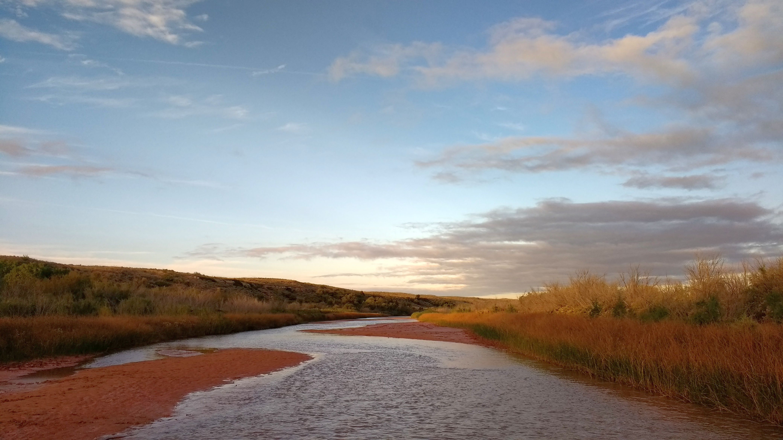

**Calibration of Biological Condition Gradient Models for Fish and Macroinvertebrates in Sandy-bottom Rivers in the Southwestern U.S.**

*Prepared for:*

U.S. EPA Region 6

and

U.S. EPA ORD

*Prepared by:*

Ben Jessup and Pat Bradley

Tetra Tech

Final Project Report

December 8, 2020



# Abstract:

Assessments of biological conditions in sandy-bottom rivers have often relied on a reference condition approach that compares assemblage data to the best observable conditions within a region. However, rivers are often subject to cumulative environmental degradation associated with intensive human activities that occur in large river valleys. Assessments might then be comparisons to reference conditions that do not represent natural biological integrity, but instead represent a shifted baseline. To recalibrate the assessment process based upon biological integrity, an assessment process was implemented in sandy-bottom rivers in southwestern U.S., starting with data sets in New Mexico. The biological condition gradient framework describes a standard scale of biological integrity that is independent of observed “best current” conditions, but instead relies on deliberation and consensus of panels of biologists and ecologists who describe expectations and measurements of assemblage data relative to biological integrity. Fish and macroinvertebrate sample data were reviewed by the experts and assigned to one of six levels along the biological condition gradient. Characteristics of the data that informed the assignment were described, including quantitative thresholds of characteristics (metrics) for each level. From the level assignments per sample, combined with characteristics of samples at each level and the rationale and rules described by the expert panels, two predictive decision models were developed that could replicate the expert decisions through application of a series of quantitative rules – a fish model and a benthic macroinvertebrate model. The models assigned samples to the same levels assigned by the experts in 87% and 93% of the samples for fish and macroinvertebrate assemblages, respectively. Sample data from comparable river systems in a broader southwestern region were then used to validate the model. The models agreed with expert assignments for 84% and 83% of the validation samples for fish and macroinvertebrate assemblages, respectively. Model predictions were never more than one level different than the expert assignments for either calibration or validation. The model rules are openly communicated as descriptions of biological expectations relative to effects of anthropogenic disturbance. At the end of the model calibration and validation process, the experts were confident that the two models could be used in other assessments of sandy-bottom southwestern U.S. rivers. Such assessments can associate samples and sites with the standardized biological condition gradient, which can be interpreted as expert-endorsed evaluations of the structure and function of the fish and macroinvertebrate assemblages.

Cover photo: Middle Rio Grande, San Antonio, NM. Photo Credit: NMED.

# Acknowledgements

This report summarizes the work of several participants in the process of calibrating a Biological Condition Gradient (BCG) for sandy-bottom southwestern rivers. The participants include ecological and biological experts, authors, contributors, reviewers, and steering committee members. The ecological and biological experts who calibrated the BCG and developed the BCG predictive model through numerous workshops, webinars, correspondences, and reviews are listed by affiliation in Appendix B. They included Kris Barrios, Becky Bixby, Will Clements, Robert Cook, Joe Flotemersch, Lynette Guevara, Anna Hamilton, Bill Harrison, Robert Hughes, Jerry Jacobi, Seva Joseph, Boris Kondratieff, Gordon Linam, Dan McGuire, Dave Peck, John Pfeiffer, Anne Rogers Harrison, Gary Schiffmiller, Shann Stringer, and Meredith Zeigler. Among the experts were also several contributors and reviewers. The primary authors and facilitators were Ben Jessup and Pat Bradley of Tetra Tech. The steering committee members provided project guidance and administrative support for the contract between the U.S. EPA and Tetra Tech. They included Robert Cook, Susan Jackson, Forrest John, Steve Paulsen, and Dave Peck of the U.S. EPA, and Kris Barrios and Lynette Guevara of NMED.

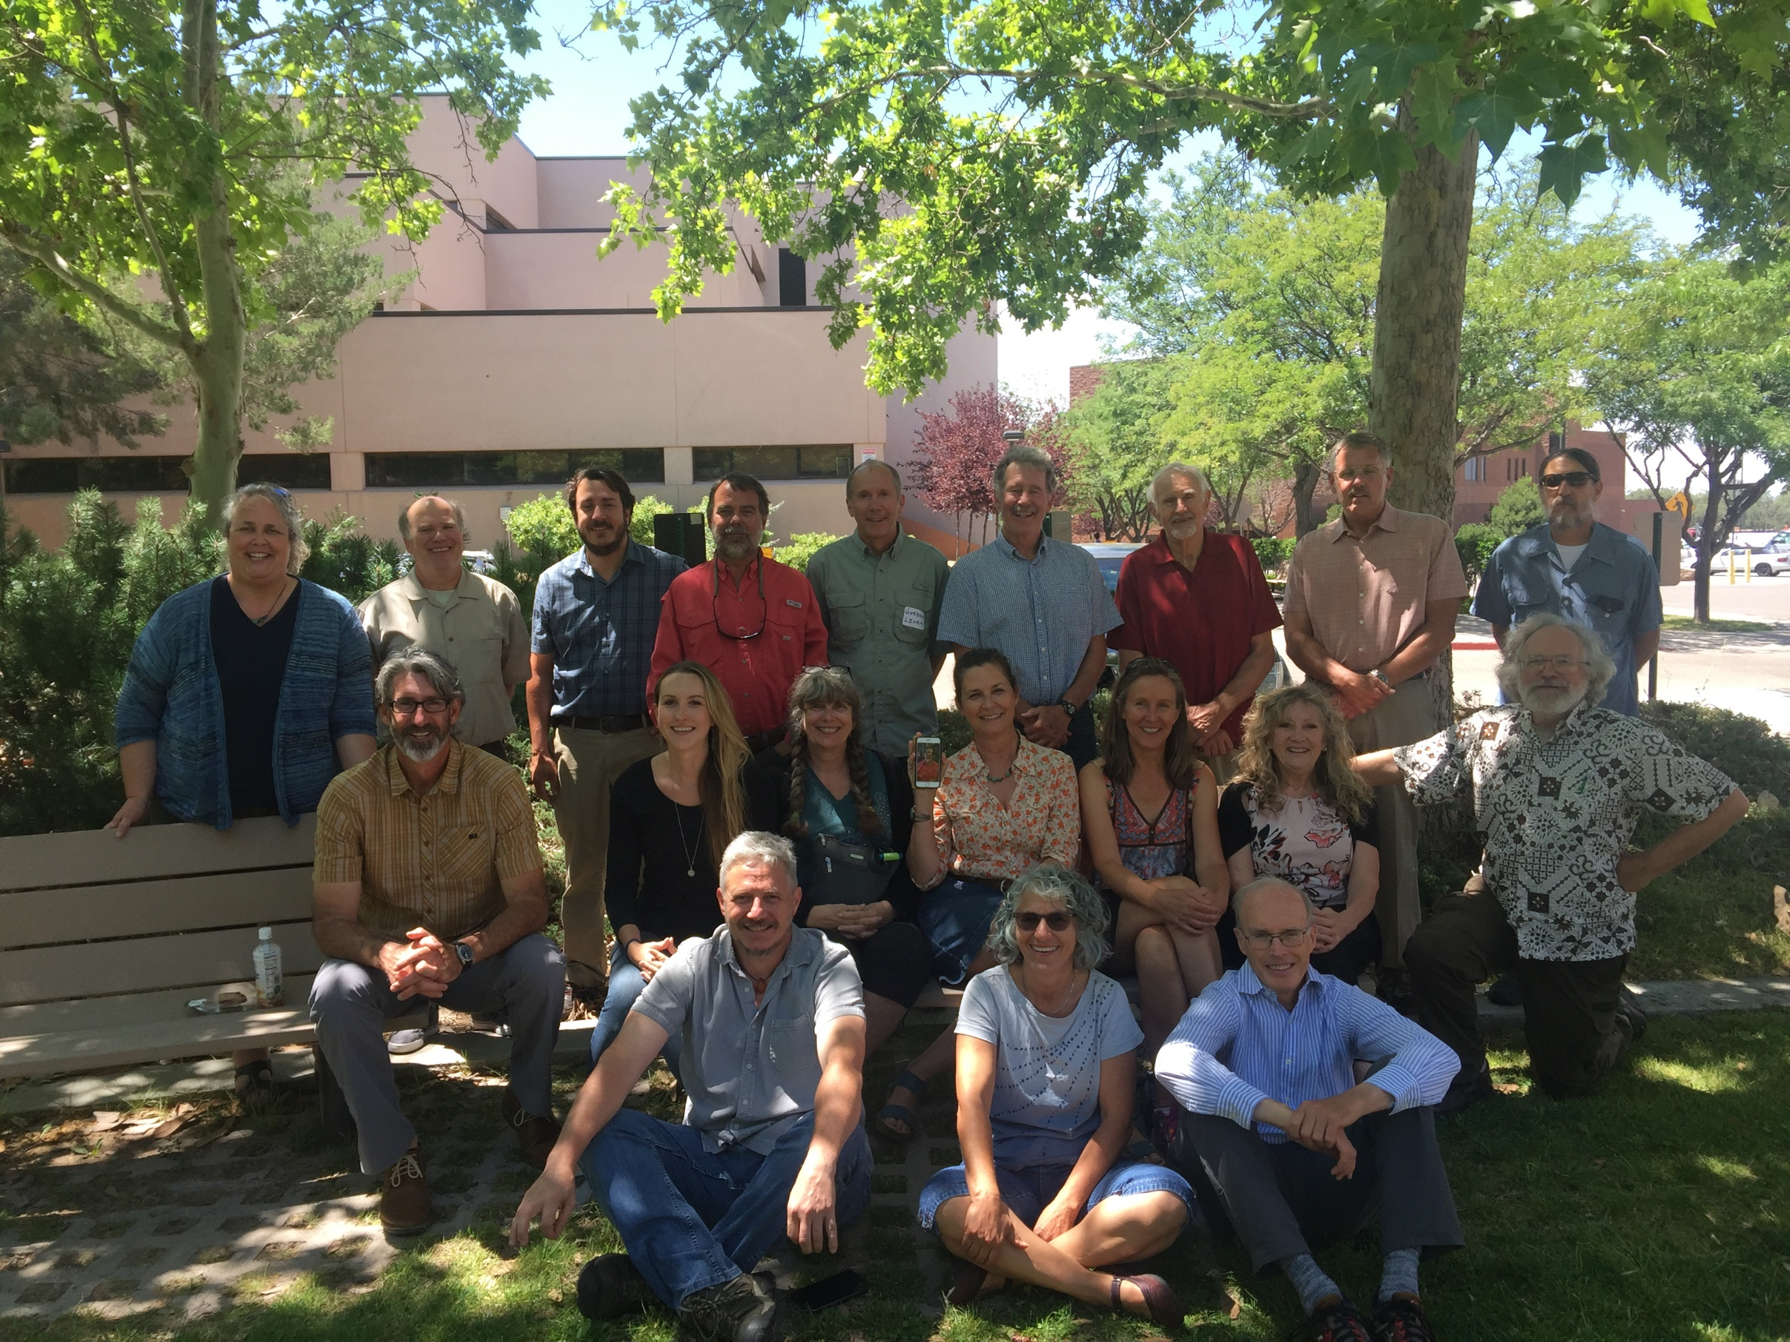

Expert panel and facilitators, Santa Fe, NM, August 2019. Photo credit: Rob Cook, U.S. EPA.

Table of Contents

Abstract: i

Acknowledgements ii

List of Tables v

List of Figures vi

1.0 Introduction 1

2.0 Data Compilation and Description 8

2.1 Benthic Macroinvertebrate (BMI) Data 8

2.2 Fish Data 9

2.3 NRSA data for stressor tolerance analysis and model validation 13

3.0 Analytical Methods 14

3.1 Site Classification 15

3.2 BCG Orientation Process 16

3.3 Taxa Attribute Assignments 16

3.4 Review of Samples 17

3.5 Model Development 21

4.0 Results 23

4.1 Site Classification 23

4.2 Taxa Attribute Assignments 24

4.3 Reviewing and Rating Samples 27

4.4 Model Development 29

4.5 Model Validation using NRSA Samples 40

5.0 Fish versus Macroinvertebrate Assemblage Comparison 44

6.0 Discussion 52

7.0 Literature Cited 57

**Appendices**

1. Glossary
2. BCG Expert Panel
3. New Mexico Large River Classification
4. Assigning Taxa to BCG Attributes
   1. File Attachment: bugs.SR.plots.zip
   2. File Attachment: Bugs_Distrib_Genus_All.pdf
   3. File Attachment: fish.SR.plots.zip
   4. File Attachment: Fish_Distrib_AllYrs.pdf
   5. File Attachment: GAM.output.20180807.xlsx
5. Benthic Macroinvertebrate BCG Attribute Assignments
6. Fish BCG Attribute Assignments
7. Benthic Macroinvertebrate Indicators Used in Developing BCG Rules
8. Macroinvertebrate Metric Box Plots by Median Rating
9. Fish Indicators Used in Developing BCG Rules
10. Fish Distributions by Rated BCG Level

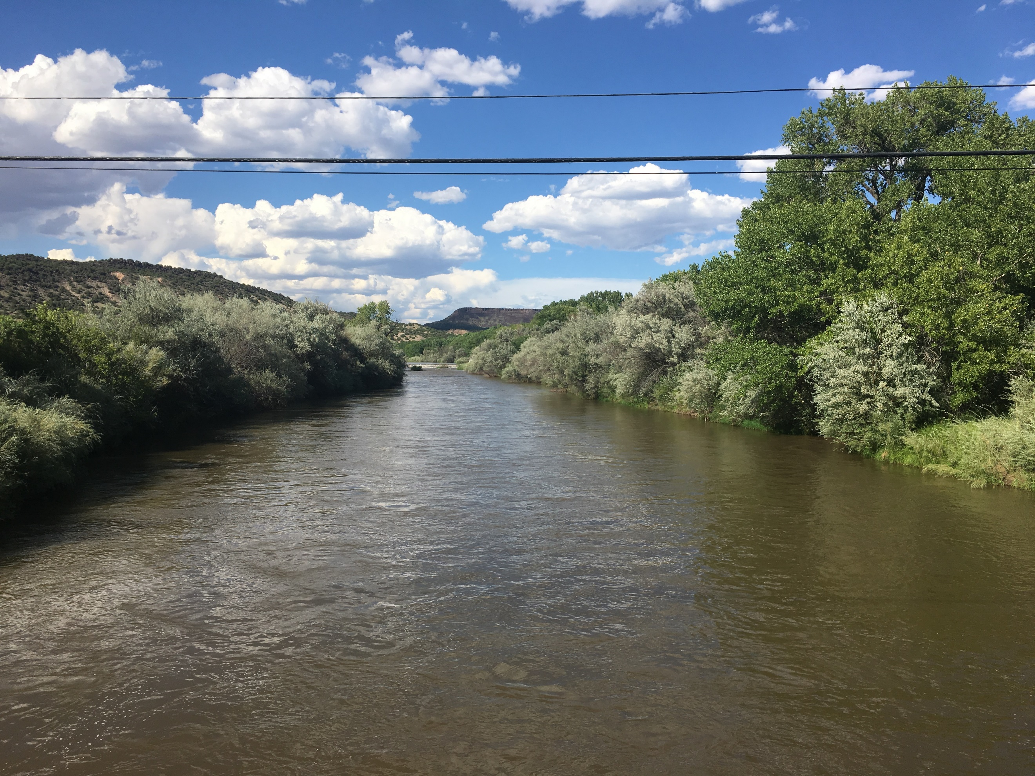

Rio Grande at Ohkay Owingeh, NM. Photo credit: Ben Jessup, Tetra Tech

# List of Tables

Table 1**.** Biological Condition Gradient attributes and their descriptions (modified from EPA 2016). 4

Table 2. Sample size (N) for benthic macroinvertebrate samples compiled and used in river Biological Condition Gradient calibration and validation. 8

Table 3. Data available for calibrating the New Mexico Rio Grande fish Biological Condition Gradient. 11

Table 4. Example of expert panel ratings and rationale for a single benthic macroinvertebrate sample with summary rating of BCG Level 3. 20

Table 5. Natural and stressor variables related to taxa occurrence in southwestern U.S. rivers. 25

Table 6. Numbers of benthic macroinvertebrate taxa assigned to the BCG attributes. 25

Table 7**.** Distribution of fish species among attribute categories from 1 August 2019 webinar consensus assignments by the expert panel. 26

Table 8**.** Fish sample ratings. 29

Table 9. Qualitative descriptions of the rationales expressed for rating samples in BCG levels. 30

Table 10. Benthic macroinvertebrate Draft #1 Biological Condition Gradient (BCG) model rules for BCG Levels 2-5 as developed during the August 2019 workshop. 31

Table 11. New Mexico large river macroinvertebrate Biological Condition Gradient (BCG) model rules (Draft #3). 32

Table 12. Macroinvertebrate model performance comparing expert ratings (medians) and model predictions (Draft #3). The numbers in the matrix are the numbers of samples by rating and prediction. The pink zone is considered model error. 33

Table 13. Draft fish narrative rules from workshop. Qualitative descriptors are shown in italics. 34

Table 14. First draft Biological Condition Gradient (BCG) fish rule developed during the August 2019 workshop. This table provides the BCG metrics, the narrative rules and the first draft numeric rules. 35

Table 15. Biological Condition Gradient Numeric Rules as refined based upon the box plots. Red font indicates rules that were modified from the August 2019 workshop rules, following webinar discussion. 39

Table 16. Distribution of median experts’ scores compared to the fish model predictions for each site. 39

Table 17. Model performance comparing expert Biological Condition Gradient (BCG) ratings (medians) and model predictions for benthic macroinvertebrate model validation samples. 41

Table 18. Comparison of median expert Biological Condition Gradient (BCG) ratings and model BCG predictions for validation samples from 19 perennial, large, sandy-bottom, southwestern, NRSA river fish samples. 43

Table 19. Comparison of predicted Biological Condition Gradient (BCG) levels between fish and BMI assemblages, showing expert ratings in cells where model comparisons were made. 44

Table 20**.** Application of the Biological Condition Gradient (BCG) for existing riverine management. 55

# List of Figures

Figure 1**.** The biological condition gradient: biological response to increasing levels of stress (modified from Davies & Jackson 2006). 2

Figure 2. Map showing the Middle Rio Grande (source: New Mexico First 2014). 7

Figure 3. Site locations for samples used in calibrating the Biological Condition Gradient for benthic macroinvertebrates. 9

Figure 4. Site locations for samples used in calibrating the BCG for fish. 13

Figure 5. Site locations for samples used in validating the Biological Condition Gradient models for benthic macroinvertebrates and fish. 14

Figure 6. General process for development of the Biological Condition Gradient model. 15

Figure 7. Example data worksheet presented to the expert panel for rating a benthic macroinvertebrate sample. 18

Figure 8. Example data worksheet presented to the expert panel for rating a fish sample. 19

Figure 9. Initial non-metric multidimensional scaling ordination using fish presence-absence data from 264 sites and showing sample regions. 24

Figure 10. Differences between individual expert ratings and sample medians for benthic macroinvertebrate calibration samples. A positive one-third level difference means that the expert estimated a slightly better condition than the expert panel median rating for the sample (e.g., expert rating was 3+ and the median was 3). 28

Figure 11. Distributions of metric values for rated calibration samples among BCG Levels. 38

Figure 12. Numbers of samples with fish model disagreements (by 1/3 Biological Condition Gradient level differences). 40

Figure 13. Differences between individual expert Biological Condition Gradient (BCG) ratings and sample medians for benthic macroinvertebrate validation samples. 41

Figure 14. Differences between individual expert Biological Condition Gradient (BCG) ratings and sample medians for fish validation samples. A positive third level difference means the expert estimated a slightly better condition than the expert panel median rating for the sample (e.g., expert rating was 3+ and the median was 3). 42

Figure 15. Fish data for site FW08UT047. 45

Figure 16. Macroinvertebrate data for site FW08UT047. 46

Figure 17. Fish data for site FW08CA035. 47

Figure 18. Macroinvertebrate data for site FW08CA035. 48

Figure 19. Fish data for site FW08NE021. 49

Figure 20. Macroinvertebrate data for site FW08NE021. 50

# 1.0 Introduction

*Regulatory Context*

The U.S. Clean Water Act (CWA) (33 U.S.C. § 1251 et seq. 1972) is the cornerstone for surface water quality protection in the United States. The CWA visionary objective is to “restore and maintain the chemical, physical, and biological integrity of the nation’s waters”. To help achieve this objective, the CWA requires states, territories, and tribes to adopt water quality standards (WQS) as provisions of their laws or regulations that define the goals (designated uses) and pollution limits (water quality criteria) for all waters within their jurisdictions. As part of the WQS process, the Environmental Protection Agency's (EPA) guidance recommends jurisdictions develop and adopt biological criteria (henceforth biocriteria) into their water quality standards (EPA 1990, 2002, 2011, 2016) to protect aquatic life that is the main component of biological integrity.

The Biological Condition Gradient (BCG) (**Figure 1**) is a scientific framework that describes how biological attributes of an aquatic ecosystem (**Table 1**) are expected to change along a gradient of increasing anthropogenic disturbance, ranging from observable biological conditions found at undisturbed or minimally-disturbed reference sites (BCG Level 1) to those found at high levels of anthropogenic stress or pressure (BCG Level 6) (Davies and Jackson 2006, USEPA 2016). The BCG calibration process includes 1) organization of sample data into interpretable presentations, 2) orientation of an expert panel to BCG concepts and project objectives, 3) assignment of taxa to BCG attributes, 4) expert rating of biological samples into BCG levels, 5) translating sample ratings into narrative rules and responsive metric values into quantitative models, and 6) validating the models with independent data. Results of the calibration include an expert predictive model that transparently replicates the expert decisions that went into BCG level assignments during the deliberations.

**BCG Attributes**

Attributes include properties of the assemblages (e.g., tolerance, rarity, native-ness) and organisms (e.g., condition, function). In the BCG model-building exercise, BCG attributes I – VI are assigned to taxa (see Table 1).

**BCG Levels**

BCG levels describe levels, or tiers, of biological response to increasing stressor levels. Six levels are defined ranging from biological conditions found at no or low stressor levels (Level 1) to those found at high stressor levels (Level 6) (Figure 1).



Figure **.** The biological condition gradient: biological response to increasing levels of stress (modified from Davies & Jackson 2006).

The BCG is part of EPA's biological assessment and criteria “toolbox” that includes biological indices, models, statistical methods, and practical guidance (Davies and Jackson 2006; EPA 2011, 2016). BCG models have been developed for wadeable streams, lakes, estuaries and coral reefs (EPA 2016). The BCG can be used in regulatory programs for protection and restoration of biological integrity (EPA 2016, Bouchard et al. 2016, Danielson et al. 2012, Yoder et al. 2015).

The BCG attribute descriptions were initially developed for permanent, hard-bottom streams that are exposed to increases in temperature, nutrients, fine sediments, and other pollutants. Over the past fifteen years, the BCG has been developed for perennial streams and wadeable rivers using expert consensus to develop narrative and numeric decision rules to assign sites to BCG levels in Alabama, California, Connecticut, Indiana, Maine, Maryland, Minnesota, New Jersey, Ohio, Pennsylvania, Rhode Island, New England, and the Pacific Northwest (Jessup and Gerritsen 2014, Gerritsen and Jessup 2007, Stamp and Gerritsen 2011, Danielson et al. 2012, Stamp et al. 2014, Gerritsen et al. 2012, Gerritsen and Leppo 2005, Paul et al. 2020, Charles et al. 2019, Hausmann et al. 2016, Stamp and Gerritsen 2019, Gerritsen et al. 2017, Schumchenia et al. 2015, Bouchard et al. 2016). These BCG calibrations address various waterbodies and assemblages, including stream macroinvertebrates (Jessup and Gerritsen 2014, Gerritsen and Jessup 2007, Stamp and Gerritsen 2011, Gerritsen et al. 2012, Gerritsen and Leppo 2005, Paul et al. 2020, Bouchard et al. 2016, Stamp et al. 2014), stream fish (Jessup and Gerritsen 2014, Stamp and Gerritsen 2011, Stamp et al. 2014), stream algae (Hausmann et al. 2016, Paul et al. 2020, Charles et al. 2019), lake fish (Gerritsen and Stamp 2014), coral reef fish (Bradley et al. 2020), and estuarine seagrass, benthic community, and primary productivity and shellfish (Shumchenia et al. 2014). The BCG has also been used to complement or refine existing state measures such as Indices of Biotic Integrity (IBIs) (Yoder et al. 2015, EPA 2016). The framework for the consensus-based model development method is also described in an EPA guide (EPA 2016).

The BCG calibration process includes compiling pertinent data on the river ecosystem and specific samples, convening a panel of ecological experts on the ecosystem and biological assemblages, orienting the panel to BCG concepts and procedures, assigning of BCG attributes to taxa occurring in the samples, assigning individual biological samples to a level of biological condition, developing the predictive numeric decision model based on expert input, and validating of the model. These steps are generally linear except in the steps for assigning biological levels and developing the model. Draft model rules are analyzed in relation to reviewed samples and new samples are reviewed to test any model revisions.

Using a similar developmental process, the BCG, as initially developed and tested, is applicable to other aquatic ecosystems and stressors with appropriate modifications (e.g., most recently a coral reef BCG has been developed for Puerto Rico and the U.S. Virgin Islands (Bradley et al. 2014, 2016, 2020; EPA 2016, Santavy et al. 2016). The process conducted for calibrating a BCG for sandy-bottom rivers of southwestern U.S. benthic macroinvertebrate and fish assemblages was similar to the processes used in preceding examples, though the waterbody type, assemblage characteristics, and ecological context were unique.

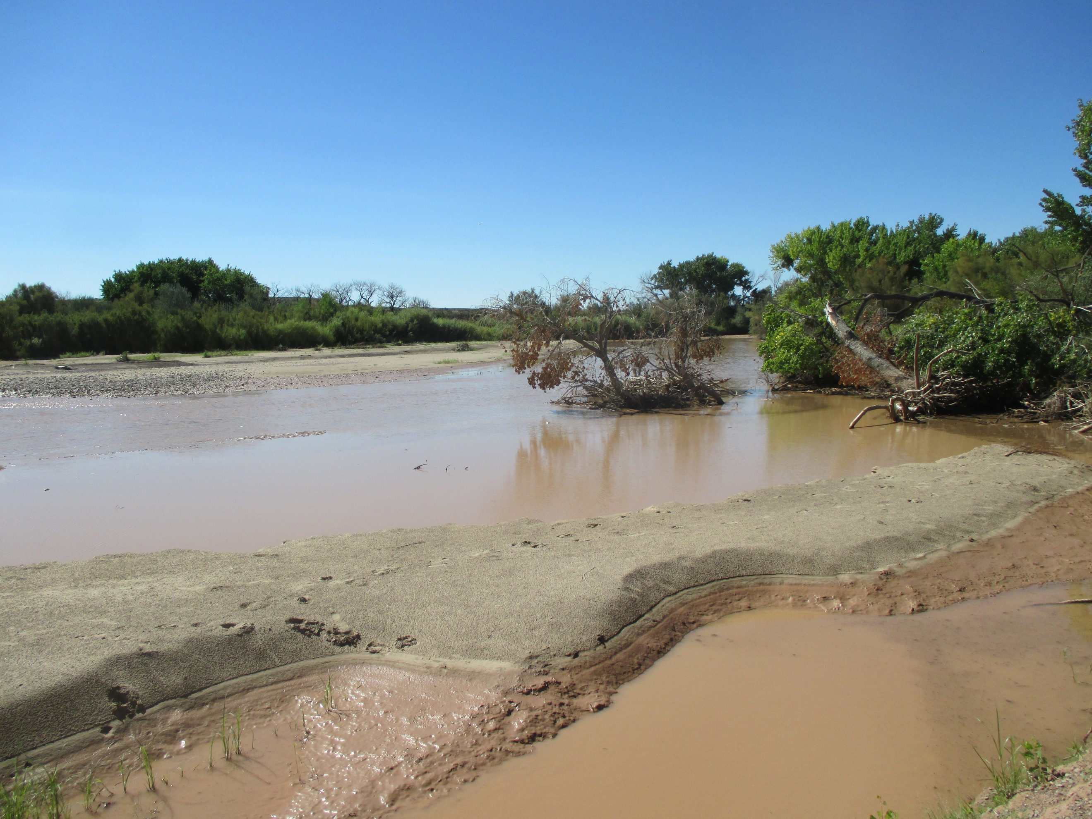

Rio Grande, NM. Photo credit: NMED.

Table **.** Biological Condition Gradient attributes and their descriptions (modified from EPA 2016).

| **Attribute** | **Description** |
| --- | --- |
| **I.** Historically documented, sensitive, long-lived, or regionally endemic taxa | Taxa known to have been supported according to historical, museum or archeological records, or taxa with restricted distribution (occurring only in a locale as opposed to a region), often due to unique life history requirements. |
| **II.** Highly sensitive taxa | Taxa that are highly sensitive to pollution or anthropogenic disturbance. Tend to occur in low numbers relative to total population density, but they might make up a large relative proportion of richness. The distinguishing characteristic for this attribute category was found to be sensitivity and not relative rarity, although some of these taxa might be uncommon in the data set (e.g., very small percent of sample occurrence or sample density), therefore, these are the first to disappear with disturbance or pollution. |
| **III.** Intermediate sensitive taxa | Taxa that are abundant in relatively undisturbed conditions but are sensitive to anthropogenic disturbance/pollution. They have a broader range of tolerance than Attribute II taxa and can be found in reduced density and richness in moderately disturbed or polluted stations. These taxa often comprise a substantial portion of natural communities. |
| **IV.** Intermediate tolerant taxa | Taxa that commonly comprise a substantial portion of an assemblage in undisturbed habitats, as well as in moderately disturbed or polluted habitats. They exhibit physiological or life-history characteristics that enable them to thrive under a broad range of thermal, flow, or oxygen conditions. Many have generalist or facultative feeding strategies enabling utilization of diverse food types. These species have little or no detectable response to moderate stress, and they are often equally abundant in both reference and moderately stressed sites. |
| **V.** Tolerant taxa | Tolerant taxa are those that typically comprise a low proportion of natural communities. These taxa are more tolerant of a greater degree of disturbance and stress than other organisms and are, thus, resistant to a variety of pollution or habitat induced stress. They may increase in number (sometimes greatly) under severely altered or stressed conditions. These are the last survivors in severely disturbed systems and can prevail in great numbers due to lack of competition or predation by less tolerant organisms. |
| **VI.** Non-native or intentionally introduced species | Any species not native to the ecosystem. Species introduced or spread from one region of the U.S. to another outside their normal ranges are non-native, or non-indigenous. This category also includes species introduced from other continents and referred to as “alien” species. |
| **VII.** Organism condition | Organism condition includes direct and indirect indicators such as fecundity, morbidity, mortality, growth rates, and anomalies (e.g., lesions, tumors, and deformities). |
| **VIII.** Ecosystem function | Ecosystem function refers to processes required for the performance of a biological system expected under naturally occurring conditions (e.g., primary and secondary production, respiration, nutrient cycling, and decomposition). Assessing ecosystem function includes consideration of the aggregate performance of dynamic interactions within an ecosystem, such as the interactions among taxa (e.g., food web dynamics) and energy and nutrient processing rates (e.g., energy and nutrient dynamics) (Cairns 1977). |
| **IX.** Spatial and temporal extent of detrimental effects | The spatial and temporal extent of stressor effects includes the near-field to far-field range of observable effects of the stressors on a water body, for example, groundwater pumping in Kansas resulting in change in fish composition from fluvial dependent to sunfish. |
| **X.** Ecosystem connectance | Access or linkage (in space/time) to materials, locations and conditions required for maintenance of interacting populations of aquatic life. For example, levees restrict connections between flowing water and floodplain nutrient sinks (disrupt function); dams impede fish migration, spawning. |

*New Mexico Sandy-bottom Rivers*

This report demonstrates how the BCG framework has been successfully applied for sandy-bottom rivers in New Mexico. The biological conditions of sandy-bottom rivers have been studied extensively in the U.S. (Moyle and Nichols 1973, Karr et al. 1985, Sublette et al. 1990, Rinne and Platania 1994, Linam et al. 2002, Goldstein and Meador 2004, Rinne et al. 2005, Jacobi et al. 2006, Hoagstrom et al. 2010, Archdeacon et al. 2015 and 2018, Sallenave et al. 2010, Paul et al. 2020) and in other countries (Hughes et al. 2009, Bazzanti 1991 and 2000, Close et al. 2014). In several studies, the rivers are associated with considerable human development in the basin, owing to the resources available in and near rivers, including fisheries, floodplain agricultural potential, development potential in broad valleys, navigation and transport, water withdrawal, waste disposal, and recreation (Allan et al. 2005, Cowley et al. 2007, Karr et al. 1985, Lammert and Allan 1999, Poff and Allan 1995, Sallenave et al. 2010, Schlosser 1982). According to the Clean Water Act (33 U.S.C. § 1251 et seq. 1972), natural biological integrity is to be protected from degradation in U.S. aquatic systems. However, recognition of the natural biological potential in rivers is challenging when disturbance is ubiquitous and biological monitoring is relatively recent compared to river disturbance. There might be no observable and appropriate rivers representing undisturbed reference conditions for determining natural biological integrity. In the reference condition approach (Hughes et al. 1986, Stoddard et al. 2006), assessments are made by comparison of biological conditions at test sites to biological conditions at relatively undisturbed systems, also known as the reference condition. When the best observable reference condition is lower along the disturbance gradient than “minimally disturbed” (Stoddard et al. 2006), the condition of sites being accessed is compared to the best of what’s left (e.g., the shifted baseline; Kopf et al. 2015, Pauly 1995).

Typical of many southwestern rivers, New Mexico rivers have been greatly altered by dams, diversions, and channel alterations, substantially degrading biological condition. New Mexico has three distinct river systems: the Rio Grande, which flows directly to the Gulf of Mexico; the Canadian River, which eventually drains into the Mississippi River; and the San Juan and Gila rivers, which drain into the Colorado River. The Pecos River drains into the Rio Grande in Texas and is considered part of the Rio Grande system. Numerous smaller rivers and creeks either drain into one of these three systems or, in a few cases into closed basins with no outflow (Morris et al. 2003).

In this study, the BCG was calibrated for benthic macroinvertebrates (BMI) and fish in sandy-bottom New Mexico rivers. Although the New Mexico Environment Department (NMED) Surface Water Quality Bureau (SWQB) has been able to develop quantitative nutrient and sediment thresholds for implementing narrative criteria in wadeable streams, no assessment procedures have been developed for non-wadeable rivers. The highly altered nature of these waterbodies in New Mexico and the lack of adequate datasets created challenges for threshold development. Therefore, these systems, which provide an important water source for portions of the state’s population and agricultural needs, have gone unassessed for nutrients and sediment. The characteristics of these rivers have been so greatly altered by dams, diversions, and channel alterations that traditional means of developing thresholds such as least-disturbed reference condition and stressor response analyses are not applicable.

Fish and macroinvertebrates assemblage evaluations are integral components of water monitoring and water quality management programs because they respond to environmental gradients and anthropogenic disturbances (Herlihy et al. 2020). Fish are relatively long-lived so they can reflect the cumulative impact of multiple disturbances occurring over long periods (several years) as opposed to other assemblages having generally shorter lifespans (Karr and Dudley 1981, Karr et al. 1986, Benejam et al. 2015, Barbour et al. 1999). Fish are also generally more mobile, linking organism structure and function with environmental factors and physical disturbance at multiple spatial extents (Hughes et al. 2009, Benejam et al. 2015, Lammert and Allen 1999). Because they are mobile, fish may be able to avoid pollutants or other stresses that would adversely affect more sessile organisms (e.g., benthic macroinvertebrates and algae). Fish assemblages can indicate the quality or presence of many features of the river ecosystem, such as food, habitat, migration barriers, environmental contamination or appropriate sediment/substrate and flow conditions for spawning. Benthic macroinvertebrates are generally less mobile than fish, have shorter life spans, respond to different stressors, and respond to stressors over shorter periods. Using both assemblages in assessments indicates conditions that are suitable for both or to only one (Jessup and Pappani 2015).

Predictive BCG models were developed through an expert consensus process using benthic macroinvertebrate (BMI) and fish samples from New Mexico, focusing on the Middle Rio Grande (MRG). The expert panel consisted of biologists and ecologists familiar with these assemblages and river systems (**Appendix B**). The models were validated using samples from sandy-bottom rivers throughout southwestern U.S. Development of a BCG for New Mexico’s sandy-bottom rivers can be used to develop quantitative thresholds to improve the state’s ability to sustain, rehabilitate and protect those river resources.

For BMI, there were not enough MRG samples for calibration of the BCG using only MRG samples. The BCG assessment therefore used samples from throughout the state for rivers that were known to be perennial and to have relatively low gradients with predominantly sandy substrates. The major rivers in New Mexico, from which samples were collected and used in the BCG calibration included the Rio Grande, Canadian River, Rio Chama, Pecos River, Gila River, and San Juan River. Samples from predominantly sandy reaches (generally > 70% sand or finer substrate) were used in the assessment. Experts familiar with the site locations offered qualitative assessments of the sand or cobble substrates at sample sites and discounted samples from cobble-dominated reaches. Some of the rivers were wadeable at times, but were not typically assessed using the stream macroinvertebrate assessment tools (Jacobi et al. 2006).

For fish, the calibration was focused on the MRG, which extends from Cochiti Dam north of Albuquerque downstream to Elephant Butte Reservoir, a distance of 174 miles (**Figure 2**). The MRG watershed represents about 14% of the entire Rio Grande basin, or 24,760 mi2. There are three major mainstream structures that divert water into 795 miles of levees, drains, and canals; two of which, Isleta and San Acacia, have the capability under low flow conditions to divert all water from the Rio Grande, thereby potentially eliminating all surface flow from a 110 mile reach between Isleta and Elephant Butte Reservoir (Finch et al. 1995). These MRG controls have had profound effects on river morphology and hydrology, resulting in a river that is considerably different than it was historically (Dudley and Platania 1997). The markedly reduced habitat complexity and altered flow regime has ongoing impacts on aquatic organisms (Hoagstrom et al. 2010, Horan et al. 2000).

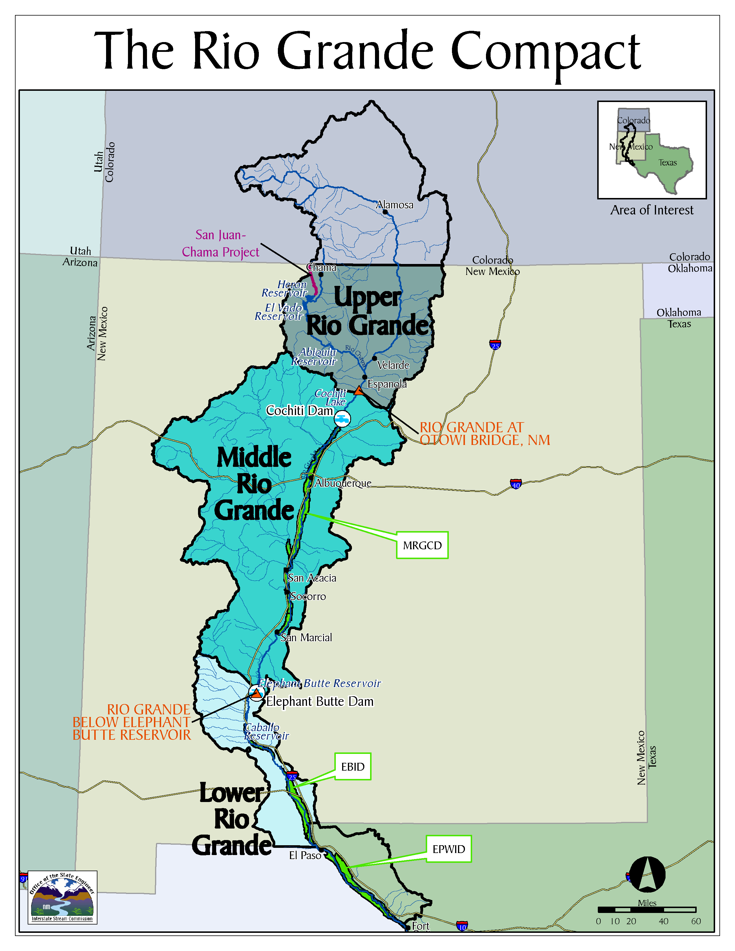

Figure . Map showing the Middle Rio Grande (source: New Mexico First 2014).

# 2.0 Data Compilation and Description

Data compilation emphasized existing sample data that could be used in the BCG calibration. Those data included primarily NMED monitoring data for macroinvertebrates and multiple sources for fish. Although multiple samples and sources were available for BCG model calibration, the numbers and types of samples were reduced to those that were sampled using consistent methods and that could be interpreted and reviewed by the expert panel. In addition to the biological sample data, information was collected about the natural and disturbance conditions at the sample sites when it was readily available in existing data sets.

## 2.1 Benthic Macroinvertebrate (BMI) Data

Macroinvertebrate data were compiled from three data sources: the NMED SWQB monitoring database, the National Rivers and Streams Assessment (NRSA) surveys, and the New Mexico Museum of Natural History and Science (MNHS) (**Table 2**). The local NRSA data (in NM and near NM in AZ, CO, KS, TX, and UT) were used for model calibration and the regional NRSA data (southwestern states) were used in model validation. One sample was created virtually to simulate a sample that would meet Level 2 rules. The data sets were scrutinized during classification exercises (Section 3.1) and were then reduced to samples that were valid for BCG model calibration. Sites were limited to large systems (Strahler order 5 or larger), which included all reaches of the Rio Grande in New Mexico as well as other river systems. Forty-four samples from 39 sites were reviewed and included in model calibration (**Figure 3**).

NMED and NRSA samples were collected with kick-net methods at systematically-placed transects and include multiple habitats. Rivers could be wadeable or boatable. In wadeable systems, the samples were collected using D-frame or kick-nets at several locations within the river channel. In boatable systems, samples were collected from littoral plots at riversides. Target sub-sample size was usually 300 organisms and taxa were identified to the lowest practical level, which was typically genus.

Table 2. Sample size (N) for benthic macroinvertebrate samples compiled and used in river Biological Condition Gradient calibration and validation. NMED – New Mexico Environment Department; NRSA – National River and Stream Assessment; NM MNHS – New Mexico Museum of Natural History.

|  |  |  |  |  |  |
| --- | --- | --- | --- | --- | --- |
|  | N - complete data set | N – reduced to valid samples | N – Used in model calibration | N – Used in model validation | N – final ratings |
| NMED | 144 | 61 | 30 | 0 | 22 |
| NRSA 0809 - local | 51 | 47 | 22 | 0 | 22 |
| NRSA 08091314 - regional | 118 | 118 | 0 | 20 | 18 |
| NM MNHS | 48 | 0 | 0 | 0 | 0 |

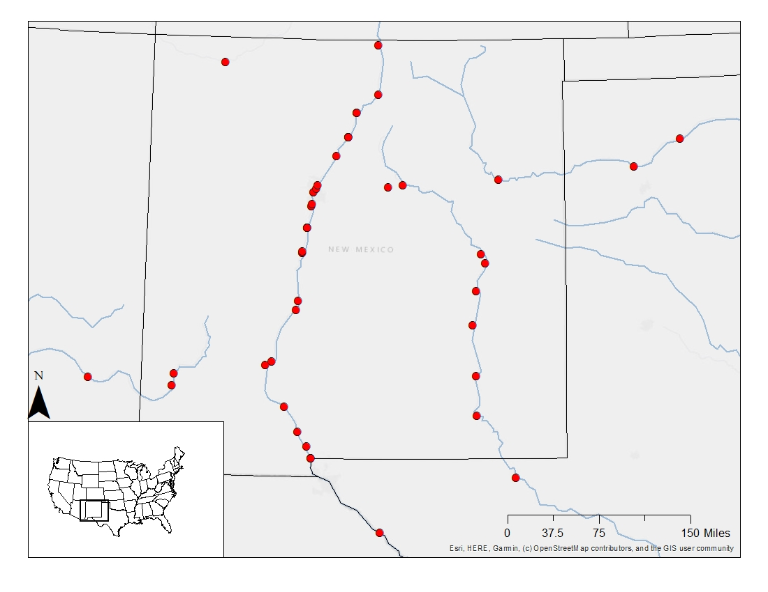

Figure . Site locations for 44 samples (39 sites) used in calibrating the Biological Condition Gradient for benthic macroinvertebrates.

## 2.2 Fish Data

**Methods.** Almost all stream/river fish are collected using one of two methods (e.g., electrofishing or seining). The method used depends on the physical characteristics of the waterbody, study protocol, and sampler preference. In larger streams and rivers seine netting or boat-mounted electrofishing is typically used. In smaller streams backpack-mounted electrofishing and/or seine netting is common.

***Electrofishing***

Electrofishing is a common scientific survey method used to sample fish populations to determine abundance, density, and species composition. Electrofishing establishes an electric field in the water. When exposed to the electric field the fish swim toward it and are captured alive in a dip net. Electrofishing is considered to be size selective, with large fish more susceptible to capture than small ones (Wiley and Tsai 1983).

* In boat electrofishing. the boat itself is the cathode and the anode(s) are generally mounted off the bow. The stunned fish are captured by netters on the boat.
* Backpack units are carried by the operator, who wades with the unit, holding a pole-mounted anode and trailing a cathode. The operator is accompanied by one or more assistants who capture stunned fish with dip nets.
* Towed barge electrofishers operate similarly to backpack electrofishers, with the exception that the generator is located on a floating barge instead of on a backpack.

***Seining***

Seiningemploys a net that hangs vertically in the water with its bottom edge held down by weights and its top edge buoyed by floats. Seines can be deployed from the shore as a beach seine, or from a boat. Seining is a very effective technique for collecting small individuals but is less effective for large fish.

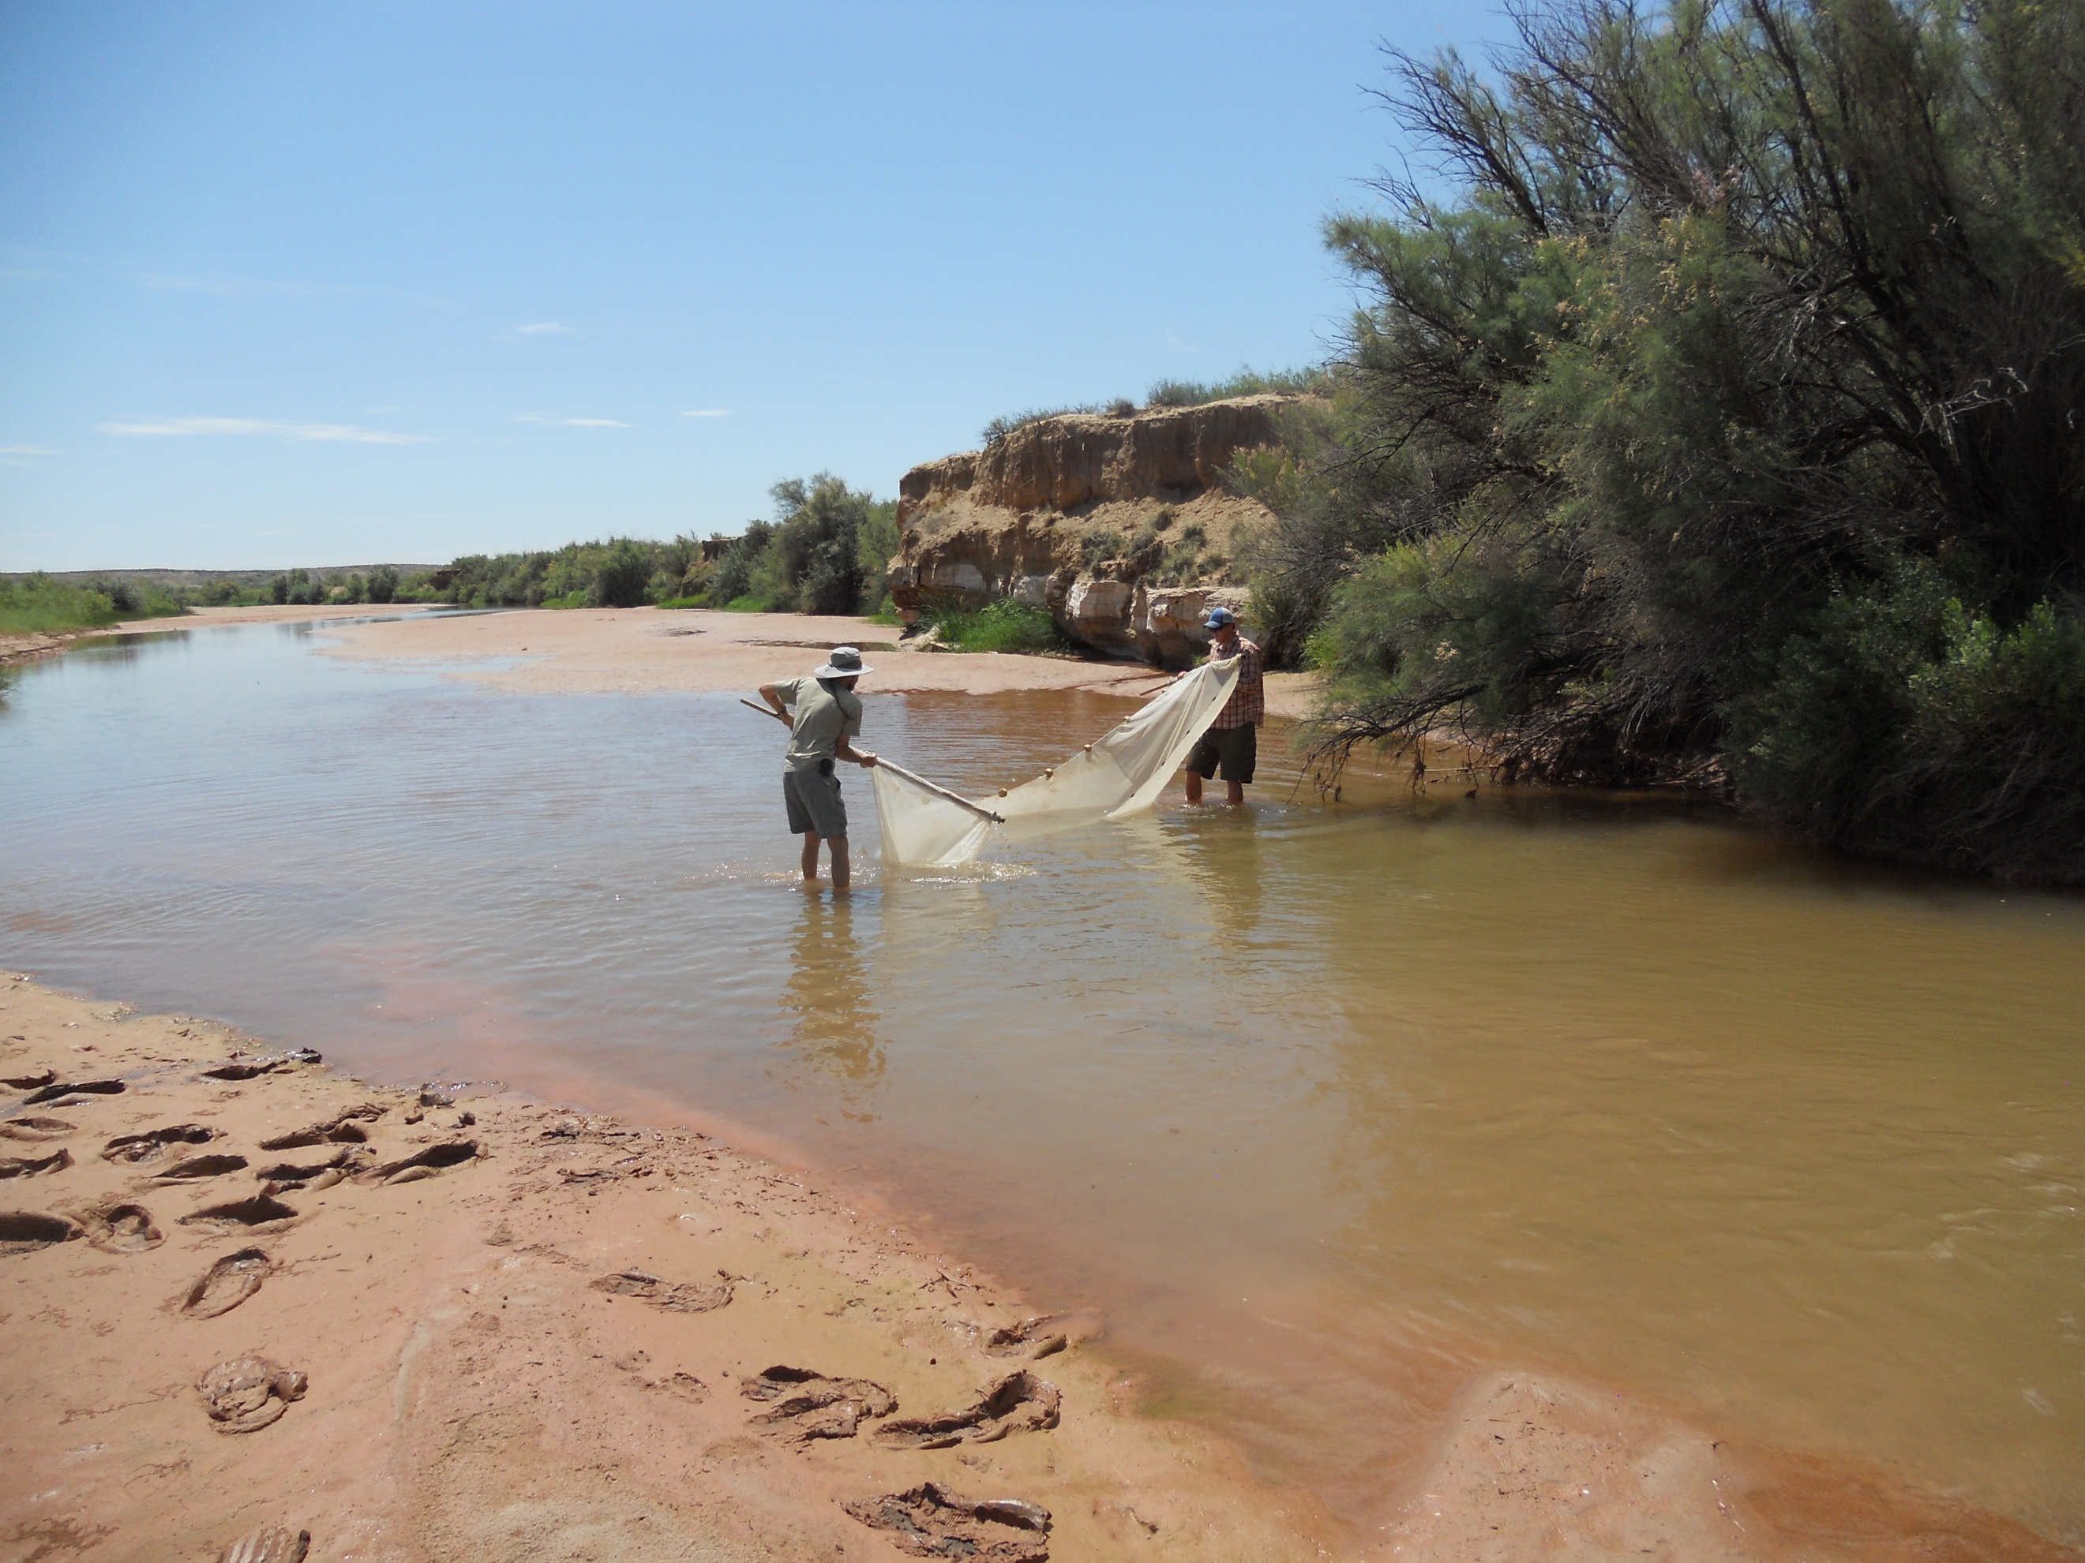

Fish Seining, Pecos River. Photo Credit: NMED.

***New Mexico Fish Data Sources.***

A database was compiled for a prior NMED project (Tetra Tech, unpublished report) that included fish collection records from a variety of State and Federal agencies, as well as records from the Museum of Southwestern Biology (MSB) at UNM. Additional data were compiled from U.S. Fish and Wildlife Service (USFWS) permit application data provided by Thomas Archdeacon (USFWS). After data compilation and reduction to valid samples for the BCG calibration exercises there were 1083 samples. Of those, 66 samples from 29 sites were reviewed for model calibration and 20 were used in validation (**Table 3**). The samples were almost entirely from the MRG (**Figure 4**). Other data sets were identified, but not used, such as New Mexico Department of Game and Fish samples collected in the Gila River, lower Pecos River, Chama River, Upper Rio Grande, and tributaries to the Rio Grande, and Pecos and Canadian Rivers. These data were not used because they were not from the MRG mainstem.

Table . Data available for calibrating the New Mexico Rio Grande fish Biological Condition Gradient. MSB – Museum of Southwestern Biology; NRSA – National River and Stream Assessment; USFWS – United States Fish and Wildlife Service; USGS – United States Geological Survey.

|  |  |  |  |
| --- | --- | --- | --- |
| Data Source | Total Samples | Reviewed Calibration | Reviewed Validation |
| Fish Ecology Report | 12 | 3 |  |
| Rio Grande at Isleta 1994-95 (;;) | 3 | 2 |  |
| MSB | 50 | 3 |  |
| NRSA | 137 | 1 | 20 |
| Sublette | 290 | 11 |  |
| USFWS | 585 | 46 |  |
| USGS | 6 | 0 |  |

***University of New Mexico Museum of Southwestern Biology***

Data from the museum covers a large spatial area and time period. The digitized records were limited to counts of individuals that were voucher specimens.

***The Fishes of New Mexico (Sublette et al. 1990)***

The longest temporal coverage of fish data (1925 -1968) comes from the collections summarized by Sublette et al. (1990) in “The Fishes of New Mexico”. This dataset covers a large spatial area but is only presence/absence and could not be used to calculate relative abundance. Because data were collected prior to, and just after the construction of the Isleta, San Acacia and Angostura diversion dams, it was used to provide historical context regarding species presence (e.g., reference condition).

***United States Fish and Wildlife Service (USFWS)***

The Rio Grande silvery minnow (RGSM; *Hybognathus amaraus)* is a federally-endangered species. The goal of the Rio Grande Silvery Minnow monitoring program is to provide overall status and trend updates on the species. The program has been in place since 1993 and consists of 20 sites that are monitored monthly by performing 18–20 seine hauls at each site (USFWS 2010). The 20 sites were chosen based on access, land ownership, and spatial distribution, and on how efficiently surveys can be conducted (USFWS 2010). Although the program is focused on the RGSM, detailed fish assemblage metrics were generated on 17 species collected during the monitoring efforts. Additional USFWS permit data were provided by USFWS for years 2013-2018.

***NMED/SWQB: Fish Ecology Report***

The SWQB’s main purpose with respect to fish survey efforts is to characterize the entire fish assemblage regardless of threatened and endangered status or recreational desirability. Electrofishing is the preferred method of capture; backpack electrofishing for small to mid-sized streams and boat-mounted electrofishing for larger rivers. Fish are collected using a single-pass technique, with all available habitats being sampled (NMED/SWQB 2013). Total number of each species captured is enumerated and recorded. Visual observations of external anomalies (deformities, fin erosion, lesions, tumors, etc.) are documented.

***United States Geological Survey (USGS)***

Data from the USGS were collected as part of the National Water-Quality Assessment (NAWQA) Program. The USGS implemented NAWQA in 1991 to develop long-term consistent and comparable information on streams, rivers, ground water, and aquatic systems in support of national, regional, state, and local information needs and decisions related to water-quality management and policy. The period of record for the USGS dataset only spans one decade and contains six samples collected by electrofishing.

***National Rivers and Streams Assessment (EPA 2017)***

NRSA is part of EPA’s National Aquatic Resource Surveys, which are designed to assess the status of and changes in quality of the nation’s coastal waters, lakes and reservoirs, rivers and streams, and wetlands (EPA 2020). The surveys are implemented on a five-year rotating basis (2008-09, 2013-14, 2018-19). One NRSA site from the Upper Rio Grande was assessed during model calibration. NRSA sites from the southwestern region and outside of the MRG were the exclusive data source for validation. The primary data collection method for NRSA fish samples is boat electrofishing; seining is employed if conductivity is too high or too low for electrofishing.

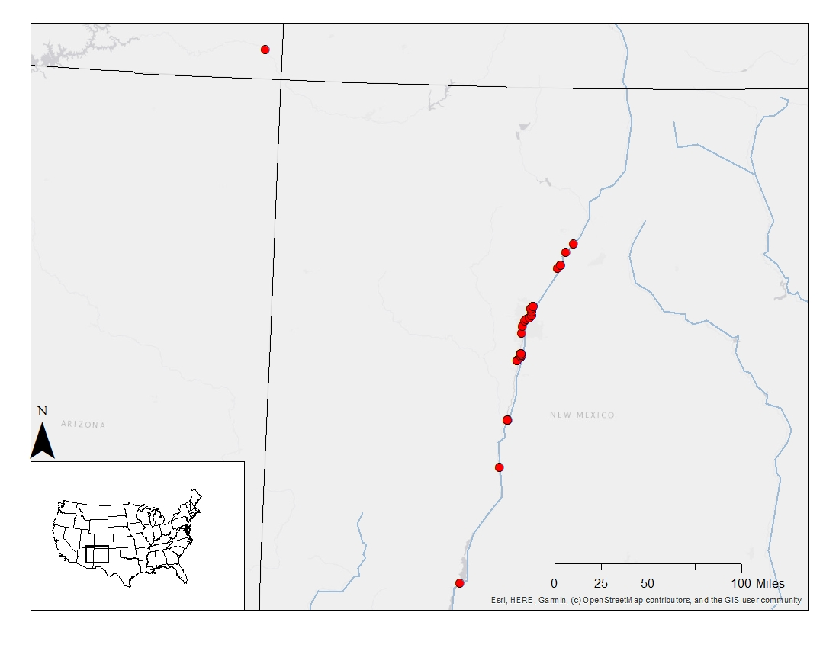

Figure . Site locations for samples used in calibrating the BCG for fish, including 25 of 29 sites (missing site coordinates for four sites)

## 2.3 NRSA data for stressor tolerance analysis and model validation

The approach for analyzing taxa sensitivities in larger systems was to use the 2008-2009 NRSA data set from New Mexico and neighboring states (AZ, UT, CO, KS, OK, and TX), limiting samples to those from 5th order and larger systems. This region and stream size limitation provides ample samples for analyzing taxa response to stressors in large lotic systems around New Mexico. The NMED and NRSA data from NM (mostly Rio Grande for fish) is smaller and probably has a narrower range of disturbances.

The experts were asked to review NRSA sample data from 20 rivers in the southwestern U.S. for validation of the final BCG models. The sites were selected based on a similarity to those evaluated for model calibration. They were large (> 10m width), sandy-bottom (> 70% sand or finer substrate), and located in southwestern U.S. (CA, CO, KS, NE, NM, NV, OK, TX, and UT) (**Figure 5**).

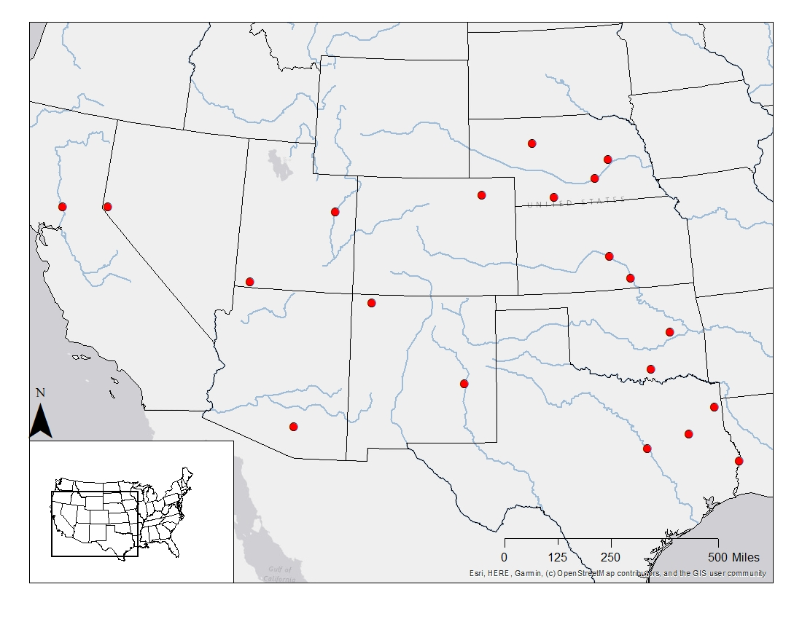

Figure . Site locations for samples used in validating the Biological Condition Gradient models for benthic macroinvertebrates and fish.

# 3.0 Analytical Methods

BCG calibration and model development for the southwestern U.S. rivers fish and benthic assemblages followed a series of steps described in technical guidance on development of a BCG (EPA 2016). The basic process included 1) organization of sample data into interpretable presentations, 2) orientation of the expert panel to BCG concepts and project objectives, 3) assignment of taxa to BCG attributes, 4) expert rating of biological samples into BCG Levels, 5) translating sample ratings into narrative rules and responsive metric values into quantitative models, and 6) validating the models with independent data (**Figure 6**). Note that steps 4 and 5 are iterative.

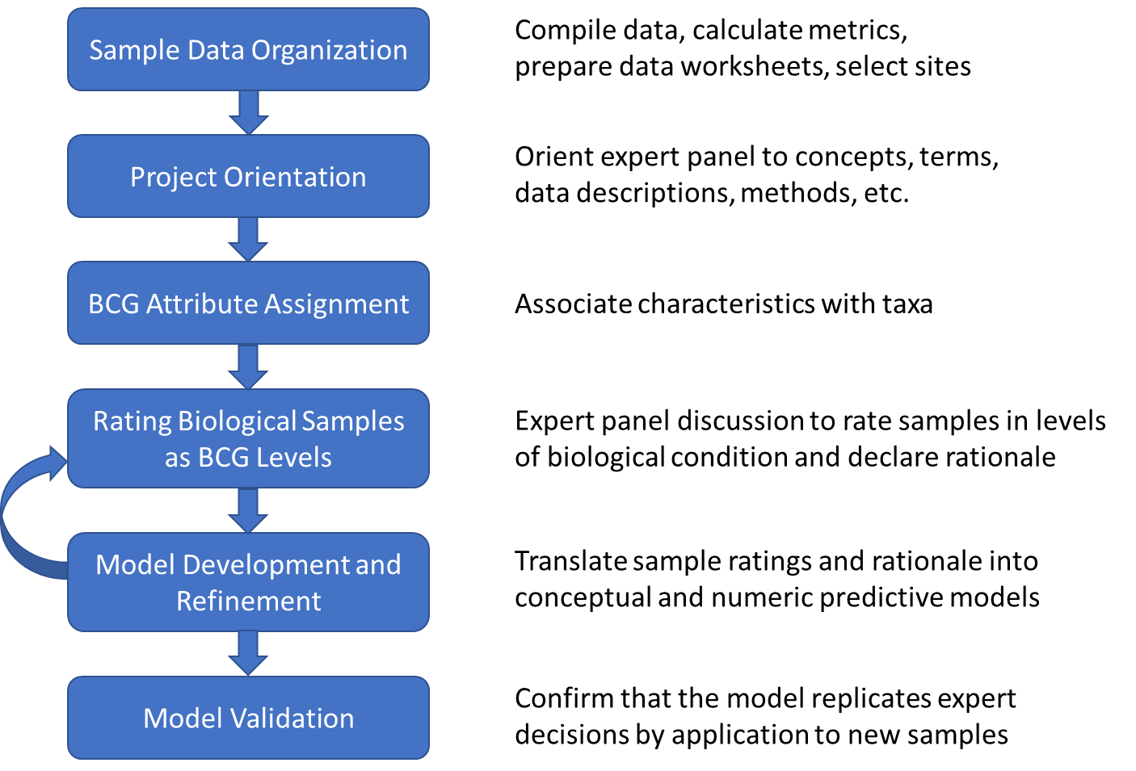

Figure . General process for development of the Biological Condition Gradient model.

## 3.1 Site Classification

Site classification analyses were conducted before engaging the expert panel so the data sets could be reduced to an adequate and manageable size for calibrating. Classification focused on sandy-bottom southwestern U.S. rivers, with a focus on the MRG because this was of particular interest to NMED. The classification results were presented to the expert panel for approval and refinement as needed during the sample review steps.

Samples were reduced to presence/absence taxa lists for each assemblage. Taxa that did not occur in at least five samples were eliminated from the analysis because rare occurrences can exert unwarranted bias on ordination results. A non-metric multidimensional scaling (NMS) ordination on the presence/absence data was conducted using PC-Ord software (McCune and Mefford 2016) for each assemblage (separately). Environmental factors (e.g., latitude, longitude, elevation, sampling region) and sample metadata (date, sample source, and sample method) were displayed in the ordination diagrams. Continuous variables were correlated to the ordination axes. Factors that were distinguishable in the ordination diagram or strongly correlated with the ordination axes were further explored as classification variables or as evidence for limiting the datasets by eliminating certain site or sample types. Additional details regarding the classification process are in **Appendix C**.

## 3.2 BCG Orientation Process

An important component of the BCG process is the establishment of a panel of outside experts familiar with the taxonomy and ecology of the aquatic biota and able to make biological assessments of environmental conditions (EPA 2016). In development of freshwater BCGs, experts have come to very precise consensus on the descriptions of individual BCG Levels and very close agreement on the BCG Level assigned to individual sites (EPA 2016; Gerritsen et al. 2017). This consensus on BCG Level descriptions depends on a comprehensive understanding of the BCG framework, terms, and concepts.

Southwestern U.S. river ecology experts were chosen based on their scientific expertise in river benthic macroinvertebrate and fish taxonomic groups, as well as assemblage structure, organism condition, ecosystem function and ecosystem connectivity. Experts included research scientists from federal and state organizations, academia, and non-governmental organizations, as well as water quality managers and natural resource managers from New Mexico (**Appendix B**).

The expert panel was convened by web conferencing several times prior to the workshop for orientation to the BCG concepts, the BCG calibration process, and taxa attribute assignments. This allowed most of the workshop time to be devoted to sample review and discussion. The contents of the orientation webinars follow the concepts and processes outlined in this report and further detailed in the Practitioner’s Guide to the Biological Condition Gradient: A Framework to Describe Incremental Change in Aquatic Ecosystems (EPA 2016).

## 3.3 Taxa Attribute Assignments

The first six BCG attributes are commonly assigned in BCG calibration exercises. Attributes II - V are largely related to pollution tolerance (including non-chemical sources of degradation). Different attributes for fish and macroinvertebrate species might be assigned when considering large rivers as opposed to the attributes assigned to the same species when assessing streams. For example, a taxon that is typical in cold, aerated streams might have moderate tolerance to pollution and its presence in a stream might be expected, and therefore it would be assigned to BCG Attribute IV, moderately tolerant. The same taxon might be uncommon in large rivers and would be sensitive to the types and degrees of pollution that occur in the warmer, less oxygenated systems. In large rivers, it might receive a BCG attribute assignment of III, somewhat sensitive. Other taxa might be considered tolerant in streams, but when they occur in rivers it is because they are appropriately adapted to natural habitat conditions and resources of sandy-bottom rivers. These might not be considered tolerant in rivers.

Because most previous BCG attribute assignments and many tolerance-value analyses have been conducted in smaller streams, taxa responses in larger lotic systems were analyzed rather than depending on relationships from stream-centric studies. With the regional NRSA sites, biological and stressor data were explored in a stressor-response analysis, plotting and tabulating responsiveness of fish and macroinvertebrates to water quality, habitat, and landscape features. The stressor-response analysis included estimation of optima and tolerance limits for each taxon that was represented by more than 10 sites in the region (**Appendix D**). Taxa distributions in southwestern U.S. rivers were also considered by the experts.

The analytical results were reviewed by the expert panels along with other indications of stressor effects, including the BCG attributes and tolerance values generally assigned in smaller stream systems. Experts had wide experience and knowledge of taxa characteristics, had analyzed commonly occurring regional taxa in southwestern U.S. rivers, were knowledgeable of relevant literature, and were familiar with similar BCG and tolerance value assignments for smaller lotic systems (e.g., BCG exercises in CA and IN, Whittier et al. 2007, and NMED tolerance values).

## 3.4 Review of Samples

During the workshop, experts broke out into two separate groups; fish and benthic macroinvertebrates. Each group of experts was asked to assign sites to BCG Levels based on their interpretation of site data: benthic macroinvertebrates (Figure 7) or fish (Figure 8). The experts provided their logic for assigning sites to BCG Levels. This expert logic was critical to the development of the BCG model – what was the information in the data set that was ecologically meaningful to the experts? And why? Each expert assessed the site data individually, recorded their individual interpretation and rationale, and then, through a facilitated process, shared their ratings and logic with the full panel. Through discussion and further testing, the expert panels developed a consensus recommendation for a set of decision rules.



Expert panel discussion, August 2019. Photo credit: Rob Cook, U.S. EPA.

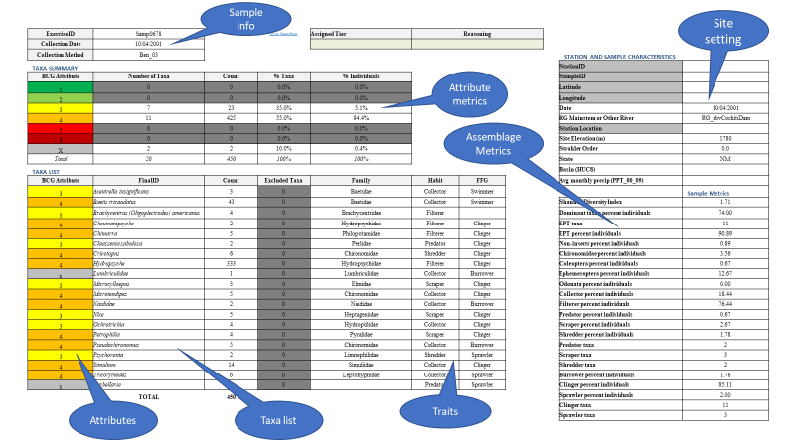

Figure . Example data worksheet presented to the expert panel for rating a benthic macroinvertebrate sample.

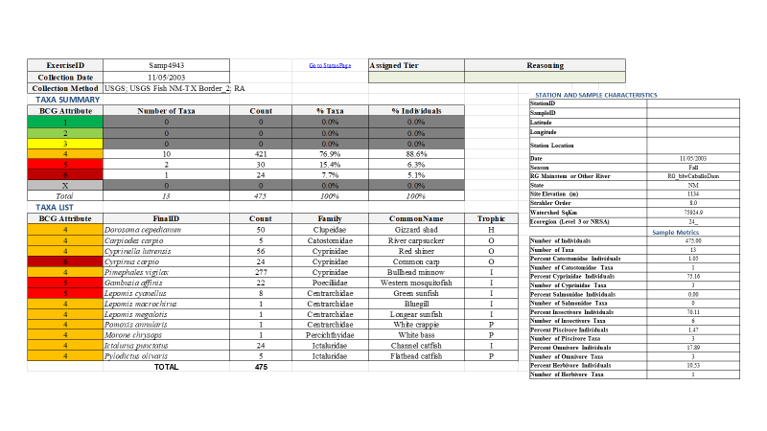

Figure . Example data worksheet presented to the expert panel for rating a fish sample.

The decision rationales expressed by panelists usually included a statement about the critical components of the sample, such as overall taxa richness, diversity, organism density, taxa that indicated stress or lack of it, trophic structure, organism condition, biomass, and other measurable metrics. Although experts were requested to provide an integer rating, representing a quintessential BCG level, they were often inclined to assign intermediate levels were assigned as ‘+’ (exhibiting characteristic of the next best conditions but not enough to rank the site in the better level) and ‘-’ (exhibiting characteristics that suggest somewhat worse conditions but not enough to rank the site in worse level). For example, a site was rated “4+” because the site was better than a normal “4” but not as good as a “3”. In each case, the expert provided their logic for the “+” or “-” rating. This decision logic provided extremely important information that indicated how shifts in assemblage structure and function signaled that a site was approaching another BCG level. Articulating these change-points and uncertainties facilitated incorporation of ecologically meaningful decision rules in the BCG model (Table 4).

Table . Example of expert panel ratings and rationale for a single benthic macroinvertebrate sample with summary rating of BCG Level 3.

|  |  |  |
| --- | --- | --- |
| Expert | BCG Rating | Rationale |
| Panelist #1 | 3+ | EPT high |
| Panelist #2 | 3+ | Good taxa richness (L2-3); good diversity; good %Target subsample; good EPT richness (L2); good Non_Hydro Trichop. (L3); Good Chiro. Richness (L3); Hi %EPT (L2-3); Lo %Non-Insects (L2-3); Lo %Chiro (L3); Sorta Hi %CG but otherwise rel. bal. trophic structure; Good SCR richness (L2-3); Good shredder richness (L3); Good clinger richness (L2-3). |
| Panelist #3 | 3+ |  |
| Panelist #4 | 3 | Prob for a low elevation UT river, good stonefly diversity, other sensitive taxa |
| Panelist #5 | 3 | good # and taxa, high EPT, low non-insect, 2 and 3 attributes |
| Panelist #6 | 3- | Good overall diversity; Good chiros and EPT diversity; Plecoptera; FFG % is a bit skewed but not bad; |
| Panelist #7 | 4+ | High EPT, low chiro % with good div, low shredders |

Whether site reviews were conducted as a group during in-person meetings or web-assisted conferences, experts would individually present to the group the sample characteristics that supported their personal ratings of the sample. When working individually on homework assignments, experts would document their rationale in writing. In both review settings, the resulting ratings and rationale would be compiled by the facilitator(s) and discussed by the group, with a goal of a group consensus BCG level assignment. When consensus was not reached, the median of the panelist’s ratings was used. The review process would continue until adequate numbers of sites were rated for the model development stage.

## 3.5 Model Development

The model development effort spread over multiple webinars and one workshop. The experts worked as one group for orientation to the BCG concepts, technical processes and dual assemblage comparisons, but attribute assignment, sample rating, and model development were in separate groups: benthic macroinvertebrates and fish. Each assemblage group followed a parallel path towards calibrating the BCG and developing the model. The expert panel members decided first individually, then by consensus, the BCG Level that best represented the biological conditions evident in the sample data. The decision criteria were expressed as statements relating sample data and metrics to the standardized BCG Level descriptions.

Model-building proceeded by converting the sample BCG level assignments (ratings) and rationale into first narrative and then numeric rules and combinations of rules. The first set of model rules were developed by the separate expert panel groups during an August 2019 workshop. The models were iteratively applied, presented, reviewed, and revised until the expert panel was in agreement that the model replicated their decision processes and accurately predicted the same BCG level that they assigned through consensus. Using this approach, the group formulated expectations for BCG levels 2 – 6 as defined in the BCG framework. The expectations were descriptions of the taxa and biological characteristics that aligned with the structural and functional descriptions for each BCG level generic description (Davies and Jackson 2006; EPA 2016). Level 1 conditions were not expected to be observable and were not conceptualized for this effort.

To determine consistent assignments of sites to BCG levels, it was necessary to formalize and quantify the expert knowledge by codifying level descriptions into a set of quantitative rules (e.g. Droesen 1996). Rules were derived from the logic statements that the experts used as rationale for their decisions on BCG levels. With quantified rules, a knowledgeable person or computer program can follow the rules to predict a BCG level comparable to a level that would be assigned by the group of experts. The set of rules and their application provides decision criteria that are transparent to water quality managers and stakeholders.

The process of rule quantification was guided by the narrative descriptions of sample characteristics at each BCG Level, any quantitative thresholds or observations expressed by the experts, and distributions of measurable sample characteristics corresponding to the descriptions (especially box-plots of metric distributions in samples at each rated level). When the metric patterns matched the expert narrative statements, then the metric was considered a good candidate for the model. If the metric patterns did not match the narrative statements, then four explanations were possible; 1) The metrics might respond to natural factors that were not recognized; 2) The experts might not have rated sites consistently; 3) The metrics might not be calculated as the experts intended; 4) There might be confounding or compounding factors that were not recognized, were not stated, or were not discernable in the data set. When these situations occurred, the expert panel was consulted, their evaluation and hypothesis for discrepancy was recorded, and the rules were revised if needed.

Model rules were expressed as a range of possible values that were expected for an assemblage measurement (metric) at a certain BCG level. The range of values acknowledges that there is a degree of uncertainty in how humans perceive quantitative thresholds for the metrics. For example, one of the macroinvertebrate rules for Level 3 is: % EPT individuals *≥* 25% (20 - 30). While the nominal value for the rule is 25%, if the sample has less than 20%, it is not at all like a Level 3 and if it has >30%, it is completely like a Level 3.

To characterize the dynamic and multifaceted nature of a biotic assemblage, the set of decision rules for each BCG level are combined with an “and” for those rules that are always expected to be met and an “or” for rules that might be superseded by other rules in the set. The experts determined how the rules for each level were to be applied: (1) all rules must be met, (2) some number of rules for that level must be met, or (3) some rules can override results of other rules (EPA 2016). After formulating the rules, rule thresholds, and combination rules, the model was presented to the expert panel for approval or adjustment.

***Model Validation***

For the BCG model validation process, experts were presented with sample taxa lists, descriptions of the sites (excluding specific names, locations, or disturbance conditions), metrics, and model results. They were encouraged to assign BCG ratings to each sample before looking at the model results. The model results were used after rating to better understand the model functions, their effects on predicted BCG levels, and to identify agreement or disagreement between the expert ratings and the model predictions. Experts returned ratings for each sample and their rationale for assigning the rating.

# 4.0 Results

## 4.1 Site Classification

A non-metric multidimensional scaling (NMS) ordination of all available samples, performed separately for each assemblage revealed that some samples were not appropriate for the BCG calibration because of differences among data sources, sampling protocols, sampling regions, and sampling years. For macroinvertebrates, the data used in the BCG calibration process was limited to NMED and NRSA samples collected after year 2000, including regional samples from neighboring states (AZ, CO, KS, TX, and UT) and excluding samples from distant sites in KS and TX. Samples collected before year 2000 might have had different taxonomic identification targets, judging from changes in taxa occurrence and frequency over time. In particular, many chironomid taxa were not identified before 2000. Samples south of latitude 30.0 (Ruidoso, NM and Perdiz, TX) and east of longitude -101.0 (Pampa, TX and Garden City KS) were on the fringes of the ordination diagram and were removed from analysis. Additional details on the classification process are included in **Appendix C**.

Site classes for benthic macroinvertebrates were not explicitly defined, although the data sources (NMED and NRSA) appeared to have different biological characteristics that could potentially be classification factors. Elevation was related to the data sources (higher elevations in New Mexico) and might be an environmental factor affecting the differences seen among data sources. The MRG sites were somewhat distinctive from other river regions in the ordination diagrams. However, using only MRG samples would limit analytical sample size and might limit the range of sample types for BCG model calibration. It was decided to allow the experts to further classify or exclude sites during the BCG calibration process. Regardless of explicit classification, all classification variables were evident when rating samples so that experts could create rules contingent upon classes or site characteristics.

For fish, there were ample samples available from the MRG for analysis. Samples above and below the MRG were distinct in ordination diagrams (**Figure 9** and **Appendix C**). The MRG was emphasized during project conceptualization and these results confirmed a decision to work with samples in that area only. Samples from multiple sources were indistinguishable in the ordination diagram and all sources with fish abundance data were considered for BCG model calibration. All potential classification variables were available for the experts to consider while they were reviewing samples in case those variables would affect interpretation of biological condition in relation to natural influences.



Figure . Initial non-metric multidimensional scaling ordination using fish presence-absence data from 264 sites and showing sample regions.

## 4.2 Taxa Attribute Assignments

***Tolerance Analyses***

There were 210 NRSA sites in the states neighboring New Mexico with stream orders greater than 4. These were mostly from xeric and southern plains regions (81 and 75 sites, respectively), as defined for the National Aquatic Resource Surveys. The stressors that were readily available as part of the NRSA data set included those related to water quality, intensive land uses, and habitat quality (Table 5). Natural variables (discharge, watershed area, channel width, and channel slope) were also included in the analysis so that responses to natural settings could also be detected.

Table . Natural and stressor variables related to taxa occurrence in southwestern U.S. rivers.

|  |  |  |
| --- | --- | --- |
| **Variable code** | **Type** | **Description** |
| COND | Stressor | Conductivity |
| NTL | Stressor | Total nitrogen |
| PTL | Stressor | Total phosphorus |
| pctCropHayGrssWS | Stressor | % of the watershed with crops, hay, or grass cover (StreamCat) |
| pctCropHayWS | Stressor | % of the watershed with crops or hay cover (StreamCat) |
| pctUrbOpnWS | Stressor | % of the watershed with urban or open land uses (StreamCat) |
| pctUrbWS | Stressor | % of the watershed with urban land uses (StreamCat) |
| W1_HALL | Stressor | Riparian disturbance |
| PCT_SAFN | Nat/Strs | % sand and fine substrate |
| CFS | Natural | Discharge (cubic feet/second) |
| WSAREA_KM2 | Natural | Watershed area in square kilometers (StreamCat) |
| XBKF_W | Natural | Average bankfull channel width |
| XSLOPE | Natural | Average water surface slope |

### Macroinvertebrate BCG Attributes

In webinars prior to the workshop, experts were asked to review taxa information and stressor-response analyses for 481 BMI taxa in the calibration and validation data sets, including identifications at genus, family and higher levels (**Appendix E**). Of those, 367 were assigned an attribute from II – VI (Table 6). The 82 taxa that were not assigned an attribute were at coarse taxonomic levels with a variety of genera, were uncommon and unknown to the experts, or were known, but with indistinct pollution tolerance characteristics. Some of the 82 “x” taxa (31) did not occur in the reviewed samples.

Table . Numbers of benthic macroinvertebrate taxa assigned to the BCG attributes.

|  |  |  |
| --- | --- | --- |
| **BCG Attribute** | **# of Taxa** | **Remark/Example** |
| I | 0 | No endemic specialists were identified by the expert panel. |
| II | 13 | All are insects. Several are in the Diptera, Ephemeroptera, and Trichoptera orders. Examples include *Drunella grandis*, *Rhyacophila coloradensis* gr., and *Oligophlebodes.* |
| III | 109 | All are insects (mostly EPT) except for one arachnid (*Testudacarus*). Examples include *Helichus*, *Tvetenia*, *Ephemerella*, *Isoperla*, and *Leucotrichia.* |
| IV | 213 | Includes various classes and orders. Examples include *Stenelmis*, *Baetis*, *Argia*, *Nectopsyche*, *Pisidium*, and *Ferrissia.* |
| V | 60 | Includes all of the oligochaetes and various other classes. Examples include *Naididae*, *Cryptochironomus*, Corixidae, and *Physa.* |
| VI | 4 | Includes *Orconectes virilis*, *Corbicula*, and *Melanoides.* |
| NA (x) | 82 | The expert panel was unfamiliar with these taxa or the taxa represented a diverse group. |

### Fish BCG Attributes

In a webinar prior to the workshop, the fish experts assigned 72 species observed in the datasets to BCG attributes (**Table 7** and **Appendix F**). This includes two taxa at higher taxonomic levels (*Lepomis* and Cyprinidae), two identifications indicating life stage (e.g. Rainbow trout *Oncorhynchus mykiss* (<200 mm total length)), and one hybrid (Cutbow *O. clarkii* x *mykiss*). Fifty-four taxa occurred in more than one sample and 27 occurred in 10 or more samples. The experts considered sensitivity to excessive fine sediments, changes in flow regime and eutrophication; along with trophic group, body size and rareness/commonality. Several species that were historically observed in the Rio Grande are now extirpated (e.g., Phantom shiner *Notropis orca*, Rio Grande shiner *Notropis jemezanus*, Rio Grande bluntnose shiner *Notropis simus simus*); whereas some species that were historically fairly common are now rarely observed (e.g., Rio Grande sucker *Catostomus plebeiu*, Rio Grande chub *Gila pandora*). The experts assigned attribute 10 (X - Ecosystem Connectivity) to the American eel *Anguilla rostrata* because it is dependent on free upstream and downstream passage for migrations between the freshwater river and the Atlantic Ocean. Most large-bodied lotic fishes are potamodromous, including suckers, catfish, gar, sturgeon, pike, salmonids and lamprey. Migration barriers, therefore, limit their productivity & sustainability.

Table **.** Distribution of fish species among attribute categories from 1 August 2019 webinar consensus assignments by the expert panel.

|  |  |  |
| --- | --- | --- |
| **BCG Attribute** | **# of Taxa** | **Remark/Example** |
| I | 5 | Includes endemic fish such as the Phantom Shiner which was historically documented but now extirpated. |
| II | 3 | Species sensitive to sediment such as the Rio Grande Chub (which is also found in the Canadian and Pecos rivers); species sensitive to loss of habitat such as the Shovelnose Sturgeon. |
| III | 3 | Moderately sensitive species such as the Longnose Dace and the Mississippi Silvery Minnow |
| IV | 4 | Species commonly found in rivers such as the River Carpsucker and the Blue Catfish. |
| V | 5 | Species that are very tolerant such as the Bluegill and Gizzard Shad |
| VI | 18 | Non-native species that are moderately tolerant of stressors such as the Gray Redhorse, which is very common in Texas streams. |
| VI-sensitive | 7 | Species that are sensitive to loss of habitat but are not native such as the Desert Sucker. |
| VI-tolerant | 19 | Non-native species that are tolerant such as the Largemouth Bass. |
| *x (unassigned)* | 7 | Examples include Bluehead Sucker and Suckermouth Minnow. |
| X (10)* | 1 | The American eel is a catadromous fish that lives in freshwater and migrates to the Sargasso Sea to spawn, indicating ecosystem connectivity. Other fish migrate throughout the rivers, but their potomadromous characteristics were secondary to their sensitivity/tolerance assignments (attributes II – V). |

*\*American eel – species is an indicator of connectivity*

## 4.3 Reviewing and Rating Samples

### Benthic Macroinvertebrates

After the August 2019 workshop, during which 26 benthic macroinvertebrate samples were evaluated, homework was assigned to the experts to assess an additional 27 samples. Some samples were from sites that were not truly sandy-bottom rivers or sampling methods were inconsistent. Those nine samples were not used in model development or summary statistics, leaving a total of 44 samples for model calibration.

The homework was conducted individually by each expert, without the interaction that was inherent to the group effort at the workshop. The ratings from independent evaluations is expected to be more variable per sample among experts because there was no immediate BCG-level rationale from multiple panelists.

The rating exercise resulted in ratings at BCG levels 3-5, with most samples assigned to level 4. There were 13 samples rated at level 3, 17 at level 4, and seven at level 5. In addition, there was one sample for which the panelists were evenly split between levels 3 and 4. After further review, the consensus was that this sample had characteristics of both levels and the tie rating was appropriate. Another five samples were given a 4-5 tie rating approved by consensus.

The variability in individual expert ratings in relation to the group median rating showed general agreement among experts. The individual ratings were within a half-level of the median in 90% of the ratings and only 3% were one level or more different than the median (Figure 10). This agreement might result from clear recognition of the characteristics of the biological conditions at each level. The agreement might also result from the rating process, which allowed panelists to discuss characteristics of the sample and rationale as they were rating samples, thus perhaps convincing other panelists of their ratings. However, the variability shown in the figure includes results from homework assignments, where discussion among panelists was limited to a few samples during webinars.

Figure . Differences between individual expert ratings and sample medians for benthic macroinvertebrate calibration samples. A positive one-third level difference means that the expert estimated a slightly better condition than the expert panel median rating for the sample (e.g., expert rating was 3+ and the median was 3).

### Fish

During the workshop, experts were asked to review 51 samples from the MRG and two samples from outside the MRG (Utah and Lower Rio Grande) that represented a range of biological conditions. Included were 10 samples that only provided presence or absence information. These were useful for historical context but were not used for calibrating a numeric model. The expert panel collaborated on a review of site data and summary indicators. The experts were asked to consider a sample, and individually record their recommended BCG level, the information they used to inform the decision, including any confounding or conflicting information, and how they resolved these conflicts (EPA 2016, Gerritsen et al. 2017). The facilitator then called on each expert to present their rating and rational, capturing the information in the projected BCG workbook.

Once all experts had provided their individual ratings, the group discussed the ratings and rationales. The median score was assigned as the site rating and experts were asked to concur on that rating as the final rating for the site. The rationale for the rating was documented. The experts found that the group discussions and ability to share knowledge were important in assigning ratings.

The experts agreed that all sites had a high degree of disturbance, including ubiquitous effects from dams and diversions, urbanization, and agriculture. The experts did not assign any sites to BCG Levels 1 or 2. All sites were rated as BCG Levels 3-6 (Table 8). All of the sites assigned to BCG Level 3 were samples from the Sublette data source, which only provided presence/absence data and not the count information necessary for rule development.

Table **.** Fish sample ratings.



## 4.4 Model Development

### Benthic Macroinvertebrates

At the August 2019 workshop, experts expressed their rationales for decisions made in rating site BCG levels. A rationale was often expressed in qualitative terms, such as “a lot of taxa” or “not enough sensitive taxa”. The rationales as expressed for individual samples were compiled into a set of narrative and qualitative rules (**Table 9**). The rationales addressed sample characteristics related to overall richness, richness of indicator taxa, composition of indicator taxa, richness and abundance of taxa with sensitive and tolerant BCG attributes, richness and abundance of functional feeding groups, richness of habitat specialists, and overall density (**Appendix G**). Some of the rules were qualified to be used in combination with other rules. For example, a dominance of chironomids were generally indicative of poor biological conditions. However, if the dominant chironomids were represented by diverse taxa, then poor conditions were not indicated. The importance of shredder taxa was expressed in rule application. If shredders were diverse, then one other requirement (rule) could be discounted and indicate better biological conditions.

In a facilitated effort, the conceptual narrative rationales were re-stated as numeric rules (Table 10). For the first set of rated samples, distributions of standard metric values in the BCG levels (categorized box plots) were presented to the experts. This led to refinement of attributes, metrics, and rationale, as well as estimation of numeric thresholds of metric values for distinguishing between levels. Draft quantitative model rules were developed for a conceptual BCG level 2, which was not observed, but could be surmised from the observations of level 3 conditions. Model rules to distinguish level 5 from level 6 were also conceptual, because no level 6 samples were identified. At level 3, 15 rules were recommended, and combination rules were discussed. At level 4, seven rules were recommended. Two rules were recommended for level 5.

Table 9. Qualitative descriptions of the rationales expressed for rating samples in BCG levels.

|  |  |
| --- | --- |
| Rule metric (short name) | Conceptual rule description |
| Richness: total | Total taxa richness is progressively higher in better biological conditions |
| Richness: EPT | High EPT taxa richness is indicative of the best conditions |
| Richness: nonHydro T | Trichoptera richness (not counting Hydropsychidae) is indicative of the best conditions |
| Composition: EPT | Relative abundance of EPT individuals is progressively higher in better conditions |
| Composition: Chiro † | Chrironomids should not be too dominant in better conditions (dependent on richness) |
| Composition: Chiro † | If Chironomids are dominant, they can indicate better conditions if they are diverse |
| Native Mollusks | The best conditions require presence of native mollusks |
| Composition: nonIns | Non-insects indicate poor conditions if relative abundance is too high |
| Attributes: 1,2,3 taxa | Sensitive and specialist taxa indicate better conditions |
| Attributes: 5 % | Tolerant taxa should not be abundant in better conditions |
| FFG: shredder | Shredder taxa richness indicates better conditions, and high shredder richness can outweigh negative indications from other rules |
| Any FFG | The community should not be dominated by any one feeding group |
| FFG: scraper taxa | Scraper taxa should be diverse in better sites and at least represented in good sites |
| FFG: collector % | Collector-gatherers should not dominate in better sites |
| Habit: clinger taxa | Clinger taxa richness is indicative of progressively better biological conditions |
| Density: % of target | Low macroinvertebrate density indicates poor conditions |

The rules were applied as a first draft of the BCG model. Most of the rated samples violated at least one of the rules established by the experts for the level assigned. Therefore, in combining rules at levels of the model, one rule was allowed to fail at levels 3 and 4. For example, the sample must meet all but one level 3 rule to be predicted as a BCG level 3. After presentation of the Draft #1 model with the samples rated at the workshop, additional samples were assigned for rating in a homework exercise.

Table 10. Benthic macroinvertebrate Draft #1 Biological Condition Gradient (BCG) model rules for BCG Levels 2-5 as developed during the August 2019 workshop.

|  |  |  |  |  |
| --- | --- | --- | --- | --- |
| BCG Metric | 2 | 3 | 4 | 5 |
| Richness: total | >=30 | >=25 | >=15 | >=10 |
| Richness: EPT | >=12 | >=10 |  |  |
| Richness: nonHydro Trichop | >=4 | >=2 |  |  |
| Composition: EPT | >=40% | >=25% | >=15% | >0 |
| Composition: Chironomidae † |  | <40% |  |  |
| Composition: Chironomidae † |  | or >10 taxa |  |  |
| Native Mollusk taxa | >0 |  |  |  |
| Composition: non-insects | <20% | <20% | <20% |  |
| Attributes: I, II, III taxa |  | >=2 |  |  |
| Attributes: V (% individuals) |  | <5% |  |  |
| FFG: shredder taxa | >6* | >=4* |  |  |
| Any FFG (% individuals) | <75% | <75% | <75% |  |
| FFG: scraper taxa |  | >=3 | >0 |  |
| FFG: collector (% individuals) | <50% | <50% |  |  |
| Habit: clinger taxa | >=11 | >=6 | >=2 |  |
| Density: % of target | >50% | >50% | >50% |  |

**NOTES**: EPT = Ephemeroptera, Plecoptera, Trichoptera; nonHydro Trichop = Trichoptera taxa excluding taxa in the Hydropsychidae family; FFG = functional feeding group. † = These two chironomid metrics are used together: either <40% individuals or > 10 taxa are indications of level 3 conditions. * = If shredder taxa are diverse, then one additional rule can fail at levels 2 and 3.

Model development included calculations within an Excel spreadsheet for applying the quantitative rules of the predictive decision model, applying the combination rules to predict membership of each sample at each level, and modifying the draft rules to reflect better discrimination of rules among levels. Model Draft #2 was experimental before addition of homework samples for calibration.

Model Draft #3 was developed with the full complement of 44 calibration samples and included minor threshold adjustments of Draft #2. For example, two rules were not discriminating in the data sets and were dropped from the final model, although the experts had perceived a rationale for their initial decisions. These rules were related to functional feeding groups including ‘any FFG’ and ‘FFG: collector %’. Distributions of metric values in rated BCG levels were used to suggest numeric rule thresholds (**Appendix H**).

One review step was for experts to reconsider ratings for samples they had already evaluated. The re-evaluations included samples that were the most variable among homework results and samples with model predictions that did not match the expert consensus. This review did not result in any changes to the initial sample ratings or to model rules (or other modification such as rule removal or addition). Rather, it resulted in acceptance of model prediction errors because the model predictions were never different than the expert predictions by more than one BCG level.

The facilitator presented the model rules to the experts for review and the rules were approved as the final Benthic Macroinvertebrate River BCG model (**Table 11**). The final Benthic Macroinvertebrate River BCG model resulted in 93% correct predictions of the expert ratings of the 44 calibration sites (**Table 12**). This model performance is similar to other BCG models across the country. There was no apparent bias in the predictions compared to the ratings.

Table 11. New Mexico river macroinvertebrate Biological Condition Gradient (BCG) model rules (Draft #3). Narrative rules in quotations are expert remarks for a sample at the BCG Level.

|  |  |  |
| --- | --- | --- |
| **BCG metric** | **Narrative rules** | **Quantitative rules (range)** |
| **BCG Level 2 (rules are conceptual: no samples identified, though some individual ratings were at level 2)** | | |
| Richness: total | "relatively high diversity & taxa richness" | >=30 taxa (25 - 35) |
| Richness: EPT | "diverse EPT" | >=12 taxa (10 - 14) |
| Richness: nonHydroT | "High number of non-Hydropsychid Trichoptera" | >=4 taxa (3-5) |
| Composition: EPT | "moderately high EPT % individuals" | >=40% (35 - 45) |
| Native Mollusks | "one native mollusk taxon" | >0 taxa (0-1) |
| Composition: nonIns | non-insects do not dominate | <=20% (15 - 25) |
| FFG: shredder taxa | "high number of shredder taxa" | >=6 taxa* (5 - 7) |
| FFG: clinger taxa | "moderately high number of clinger taxa" | >=11 taxa (10 - 12) |
| FFG: collector % | "low % collector-gatherers individuals" | <=50% (40 - 60) |
| Density: % of target | Should be able to collect a full sample | >=50% (40 - 60) |
| **Level 2**  **COMBINATION RULE** | Level 2 membership is the minimum of all rule memberships, *though if shredder taxa >5, use the second lowest rule membership | |
| **BCG Level 3** |  |  |
| Richness: total | "Decent taxa richness" | >= 20 taxa (15 - 25) |
| Richness: EPT | "good EPT richness" | >=7 taxa (5 - 10) |
| Richness: nonHydro T | "good number of non-Hydropsychid Trichoptera" | >=1 taxon (0 - 1) |
| Composition: EPT | "good %EPT" | >=25% (20 - 30) |
| Composition: Chiro | "relatively low % chironomids" (Note A) | <=40% (35 - 45) |
| Composition: Chiro | "Great chironomid diversity" (Note A) | >=10 taxa (5 - 15) |
| Composition: nonIns | "low representation by non-insect individuals" | <20% (15 - 25) |
| Attributes: 1,2,3 taxa | "good BCG attribute 3 representation" | >=2 (1 - 3) |
| Attributes: 5 % indiv. | "not too many tolerant individuals" | <=7.5% (5 - 10) |
| FFG: shredder | "good number of shredder taxa" | >=3 taxa** (2 - 4) |
| FFG: scraper taxa | "good scraper taxa count" | >=2 taxa (1 - 3) |
| FFG: clinger taxa | "high clinger taxa" | >= 5 taxa (3 - 7) |
| Density: % of target | Should be able to collect a full sample | >=50% (40 - 60) |
| **Level 3**  **COMBINATION RULE** | Level 3 membership is the second lowest of rule memberships, though if **shredder taxa >2, use the third lowest rule membership | |
| **BCG Level 4** |  |  |
| Richness: total | "Moderate taxa richness" | >=15 taxa (10 - 20) |
| Composition: EPT | "EPT relatively low % individuals" | >=15% (10 - 20) |
| Composition: nonIns | "relatively low % non-insect individuals" | <20% (15 - 25) |
| FFG: scraper taxa | "good number of scraper taxa" | >0 (0 - 1) |
| FFG: clinger taxa | "moderate clingers" | >=2 (1 - 3) |
| Density: % of target | Should be able to collect a full sample | >=50% (40 - 60) |
| **Level 4**  **COMBINATION RULE** | Level 4 membership is the second lowest of rule memberships | |
| **BCG Level 5** |  |  |
| Richness: total | "relatively low taxa richness" | >=10 (5 - 15) |
| Composition: EPT | "low % EPT individual representation" | >0.5 (0 - 1) |
| **Level 5**  **COMBINATION RULE** | Level 5 membership is the minimum of the rule memberships | |
| **BCG Level 6** No additional rules – does not meet Level 5 rules | | |

Note A: Low % chironomid individuals are expected for level 3 conditions, but if there are many individuals and diversity is high, then level 3 is indicated. Use the maximum of the two chironomid composition memberships before combination with other rule memberships.

Table 12. Macroinvertebrate model performance comparing expert ratings (medians) and model predictions (Draft #3). The numbers in the matrix are the numbers of samples by rating and prediction. The pink zone is considered model error.

|  |  |  |  |  |  |  |  |  |  |  |  |  |
| --- | --- | --- | --- | --- | --- | --- | --- | --- | --- | --- | --- | --- |
|  |  | Expert Rating | | | | | | | | | | |
|  |  | 2- | 3+ | 3 | 3- | 34tie | 4+ | 4 | 4- | 45tie | 5+ | 5 |
| Model Prediction | 3 |  | 3 | 5 | 5 | 1 |  |  | Model better than rating | | | |
| 3- |  |  |  |  |  |  | 1 |  |  |  |  |
| 34tie |  |  |  |  |  | 2 | 1 |  |  |  |  |
| 4+ |  |  |  |  |  | 1 | 1 |  |  |  |  |
| 4 |  |  |  |  |  | 1 | 4 | 3 | 2 |  |  |
| 4- |  |  |  |  |  |  |  | 2 |  |  |  |
| 45tie |  |  |  |  |  |  |  |  | 1 |  |  |
| 5+ |  |  |  |  |  |  |  | 1 | 1 |  | 1 |
| 5 |  |  |  |  |  |  |  |  | 1 | 1 | 2 |
| 5- |  |  |  |  |  |  |  |  |  |  | 3 |
| 6+ |  | Model worse than rating | | | |  |  |  |  |  | 1 |
|  | Invalid | 1 | 2 | 1 |  |  | 1 | 2 |  | 2 |  |  |

### Fish

Subsequent to the facilitated rating process, the experts provided narrative statements to describe what they expected to see for each BCG level starting from the highest quality condition observed in the data set. This narrative became the basis for BCG rule development.

BCG level 1 was not expected to occur in the MRG and was not described conceptually or with model rules by the fish experts. Although no sites were rated as BCG level 2, the experts did develop conceptual rules for level 2. The experts also developed rules for BCG level 3 based solely upon the Sublette presence/absence data; six of the eight rules were based on species data, only two were based on number of individuals. BCG levels 4, 5 and 6 were based on sites that included count information.

The experts identified a set of indicators and metrics that they used to distinguish BCG levels, including percentages of sensitive species and individuals; number of native long-lived large-bodied fish, pelagic broadcast spawners, non-native taxa and native cyprinid taxa. Full descriptions and ecological rationales for the indicators and metrics are provided in **Appendix I**.

Based upon the analysis, a set of draft narrative fish rules was developed. These narrative level descriptions that the experts developed were qualitative (e.g., sensitive and intermediate tolerant species *dominate*, *good* number of native long-lived large-bodied fish). The narrative decision rules exhibited a general pattern of decreasing richness, especially of sensitive or specialist fish, as biological condition degrades (**Table 13)**.

Table . Draft fish narrative rules from workshop. Qualitative descriptors are shown in italics. (Continued on following page)

|  |  |
| --- | --- |
| **BCG Metric** | **BCG Narrative Rule** |
| **BCG Level 2 (No survey samples were identified, rules are conceptual)** | |
| pt_Att1234 | Sensitive and intermediate tolerant species dominate (Attributes I-IV) |
| pi_Att1234 | Sensitive and intermediate tolerant individuals dominate (Attributes (I-IV) |
| nt_LLNLB | *Good* number of native long-lived large-bodied fish |
| NatvMinnAtt14 Taxa | *High* number of native Att I-IV cyprinid taxa |
| RG Silvery Minnow | Rio Grande Silvery Minnow present |
| Broadcasters | *Good* number of pelagic broadcast spawners |
| NumTrophic | All trophic groups present (piscivore, herbivore, invertivore, omnivore) |
| NonNatvTaxa | Absence of non-natives |
| **BCG Level 3** | |
| pt_Att1234 | *Good* % of sensitive and intermediate tolerant species present (Attributes I-IV) |
| pi_Att1234 | *Good* number of sensitive and intermediate tolerant individuals (Attributes (I-IV) |
| nt_LLNLB | *Fair* number of native long-lived large-bodied fish |
| NatvMinnAtt14 Taxa | *Good* number of native Att I-IV cyprinid taxa, RG Silvery Minnow not required |
| Broadcasters | Presence of pelagic broadcast spawners |
| NumTrophic | Several trophic groups present |
| NonNatvTaxa | Low percentage of non-native species |
| NonNatvPscvTaxa | Absence of non-native piscivores |
| **BCG Level 4** | |
| pt_Att1234 | *Fair* % of sensitive and intermediate tolerant species present (Attributes I-IV) |
| pi_Att1234 | *Fair* number of sensitive and intermediate tolerant individuals (Attributes (I-IV) |
| NatvMinnAtt14 Taxa | *Fair* number of native Att I-IV cyprinid taxa, RG Silvery Minnow not required |
| NumTrophic | Several trophic groups present |
| NumInd | *Moderate* density |
| NonNatvTaxa | *Moderate* percentage of non-native species |
| NonNatvPscvTaxa | Non-native piscivores may be present |
| **BCG Level 5** | |
| pt_Att1234 | *Low* % of sensitive and intermediate tolerant species (Attributes I-IV) |
| NatvMinnAtt14 | Presence of native Att I-IV taxa |
| NonNatvTaxa | *High* percentage of non-native species |
| NonNatvPscvTaxa | Non-native piscivores may be present |
| NumInd | *Low* density |
| BCG Level 6 - No additional rules – does not meet Level 5 rules | |

Numeric Fish Model – Calibration

During the workshop, experts took a first step at quantifying the fish rules, based on their ratings of the 53 samples (Table 14). Draft quantitative model rules were developed for a conceptual BCG Level 2, which was not observed, but could be surmised from the observations of the Level 3 descriptions developed from the Sublette presence/absence data. At Level 3, eight rules were recommended. At Level 4, six rules were recommended. Four rules were recommended for Level 5.

Table . First draft Biological Condition Gradient (BCG) fish rule developed during the August 2019 workshop. This table provides the BCG metrics (used in all subsequent tables), the narrative rules and the first draft numeric rules. (Continued on following page)

|  |  |  |
| --- | --- | --- |
| **BCG Metric** | **BCG Narrative Rule** | **Preliminary Numeric Rules** |
| **BCG Level 2 (No survey samples were identified, rules are conceptual)** | |  |
| pt_Att1234 | Sensitive and intermediate tolerant species dominate (Attributes I-IV) | 60% or greater of Attribute I-IV species |
| pi_Att1234 | Sensitive and intermediate tolerant individuals dominate (Attributes (I-IV) | 60% or greater of Attribute I-IV individuals |
| nt_LLNLB | *Good* number of native long-lived large-bodied fish | At least 4 species ofnative long-lived large-bodied fish |
| NatvMinnAtt14 Taxa | *High* number of native Att I-IV Cyprinid taxa | At least 6 native Attribute I-IV cyprinid species (for MRG including RG Silvery Minnow) |
| RG Silvery Minnow | RG Silvery Minnow present | At least 1 RG Silvery Minnow present |
| Broadcasters | *Good* number of pelagic broadcast spawners | At least 2 pelagic broadcast spawners |
| NumTrophic | All trophic groups present (piscivore, herbivore, invertivore, omnivore) | 4 trophic groups present (piscivore, herbivore, invertivore, omnivore) |
| NonNatvTaxa | Absence of non-natives | No non-native species |
| **BCG Level 3** | |  |
| pt_Att1234 | *Good* % of Sensitive and intermediate tolerant species dominate (Attributes I-IV) | 50% or greater of Attribute I-IV species |
| pi_Att1234 | *Good* number of Sensitive and intermediate tolerant individuals (Attributes I-IV) | 50% or greater of Attribute I_IV individuals |
| nt_LLNLB | *Fair* number of native long-lived large-bodied fish | At least 2 species ofnative long-lived large-bodied fish |
| NatvMinnAtt14 Taxa | *Good* number of native Attribute I-IV cyprinid taxa, RG Silvery Minnow not required | At least 4 native Attribute I-IV cyprinid species (for MRG including RG Silvery Minnow) |
| Broadcasters | Presence of pelagic broadcast spawners | At least 1 broadcast spawner |
| NumTrophic | Several trophic groups present | At least 3 trophic groups represented (piscivore, herbivore, invertivore, omnivore) |
| NonNatvTaxa | Low percentage of non-native species | No more than 1 non-native species |
| NonNatvPscvTaxa | Absence of non-native piscivores | No non-native piscivores |
| **BCG Level 4** | |  |
| pt_Att1234 | *Fair* % of sensitive and intermediate tolerant species (Attributes I-IV) | 25% or greater of Attribute I-IV species |
| pi_Att1234 | *Fair* number of sensitive and intermediate tolerant individuals (Attributes I-IV) | 25% or greater of Attribute I_IV individuals |
| NatvMinnAtt14 Taxa | *Fair* number of native Attribute I-IV cyprinid taxa, RG Silvery Minnow not required | At least 3 native Attribute I-IV Cyprinid species (for MRG including RG Silvery Minnow) |
| NumTrophic | Several trophic groups present | At least 2 trophic groups represented (piscivore, herbivore, invertivore, omnivore) |
| NonNatvTaxa | *Moderate* percentage of non-native individuals | No more than 25% non-native species |
| NonNatvPscvTaxa | Non-native piscivores may be present | Non-native piscivores allowed |
| **BCG Level 5** | |  |
| pt_Att1234 | *Low* % of Sensitive and intermediate tolerant species (Attributes I-IV) | 10% or greater of Attribute I-IV species |
| NatvMinnAtt14 | Presence of native Attribute I-IV taxa | At least 1 native Attribute I-IV species |
| NonNatvTaxa | *High* percentage of non-native individuals | No more than 75% non-native individuals |
| NonNatvPscvTaxa | Non-native piscivores may be present | Non-native piscivores allowed |
| BCG Level 6 - No additional rules – does not meet Level 5 rules | |  |

Numeric rules were refined as the experts reviewed the rules and station data. Many of the errors hinged on the native cyprinid and Rio Grande Silvery Minnow rule, so the experts eliminated the Rio Grande Silvery Minnow rule for Level 3 and merged that requirement into the native minnow taxa rule. The experts also recognized that the number of individuals dropped off significantly between BCG Levels 5 and 6, so they added a rule about minimum number of individuals for BCG Level 5.

The experts’ narrative rules and reasoning, both quantitative and qualitative, were compared to data summaries of the sites evaluated by the experts. For example, if the experts determined that sensitive and intermediate tolerant taxa dominated for BCG level 3, then the percentage of sensitive and intermediate tolerant taxa in samples the panel assigned to BCG level 3 were examined (e.g., sensitive taxa ranged from 4-6 in all samples assigned to BCG level 3). Box plots were developed for each of the experts’ narrative statements, which informed thresholds for the numeric rules. Distributions of metric values in rated BCG levels were used to suggest numeric rule thresholds (**Appendix J**). The Sublette samples, which were collected between 1937 and 1978, and had only presence/absence data (no counts) were considered to be invalid for developing numeric rules, because many BCG rules depended on count data; therefore the Sublette samples are not included in the box plots (**Figure 11**). However, the Sublette information was useful in identifying species that were historically observed in the MRG. Opinions repeatedly expressed by the experts that were not expressed in the draft narrative rules were used to formulate additional rules. Some rules suggested by the panel (e.g., broadcast spawners in levels 4 and 5; native large-bodied fish species in level 5; and trophic group requirement in level 5) did not discriminate between levels and therefore were not used.

The sensitive/intermediate tolerant rule was not discriminating in the data sets and was eliminated for levels 2 and 3. A new rule that only included the sensitive species (Attribute I, II and III species) was added for BCG levels 2, 3, and 4 (**Table 16**).



Fish expert panel, August 2019. Photo credit: Rob Cook, U.S. EPA.



Figure . Distributions of fish metric values for rated calibration samples among BCG Levels. Box plots show median (central marker), intraquartile range (boxes), non-outlier ranges (whiskers), and outliers circles and stars).

Table . Biological Condition Gradient Numeric Rules as refined based upon the box plots. Red font indicates rules that were modified from the August 2019 workshop rules, following webinar discussion.

|  |  |  |  |  |  |
| --- | --- | --- | --- | --- | --- |
| **Metrics** | **2** | **3** | **4** | **5** | **6** |
| pt_Att123 | >=45% | >=35% | >=15% |  |  |
| pt_Att1234 | ~~>=45%~~  Rule deleted for Level 2 | ~~>=50%~~  Rule deleted for Level 3 | >=25% | >=10 |  |
| pi_Att1234 | >=60% | >=50% | >=25% |  |  |
| nt_LLNLB | >=4 | >=1 |  |  |  |
| NatvMinAtt14 Taxa | >=6 | >=3 | >=2 | >1 |  |
| Silvery Minnow | >=1 |  |  |  |  |
| Broadcasters | >=2 | >=1 |  |  |  |
| NumTrophic | =4 | >=3 | >=2 |  |  |
| NonNative Pct Indiv | <1% | <=15% | <=25% | <=75% |  |
| NonNatvPiscTaxa | <1 | <1 | ~~>=1~~ |  |  |
| NumInd |  | >=100 | >=50 | >=10 |  |
| Combination Rules | Must meet all rules | Must meet all rules | Must meet all rules | Must meet all rules | No additional rules. |

The fish BCG decision model was applied to 55 of the original samples (those with count data) and those results were compared to the expert BCG Level ratings for the same samples. The quantitative model was 87% accurate in replicating the expert panel assessments, with 48 accurate predictions (blue and light blue cells in **Table 16**). There were four marginal predictions (7%; grey cells; different BCG levels, but very close). There were three disagreements between the model and the expert ratings (tan cells; 5%). All model predictions were within one level of the experts’ rating (**Figure 12**).

Table . Distribution of median experts’ scores compared to the fish model predictions for each site.

|  |  |  |  |  |  |  |  |  |  |  |
| --- | --- | --- | --- | --- | --- | --- | --- | --- | --- | --- |
|  |  | Model Prediction | | | | | | | | |
|  |  | 4+ | 4 | 4- | 45tie | 5+ | 5 | 5- | 6+ | 6 |
| Rating Median | 4+ |  | 1 |  |  |  |  | Model worse than rating | | |
| 4 |  | 3 | 1 |  |  |  |  |  |  |
| 4- |  | 1 | 1 | 1 | 3 | 1 |  |  |  |
| 45tie |  |  | 1 |  |  |  |  |  |  |
| 5+ |  |  | 1 | 2 | 1 | 8 | 1 |  |  |
| 5 |  |  |  | 3 |  | 13 | 2 | 1 | 1 |
| 5- |  |  |  |  | 1 | 2 |  |  |  |
| 6+ |  |  |  |  |  |  |  |  | 1 |
| 6 |  | Model better than rating | | |  |  |  | 2 | 3 |



Figure . Numbers of samples with fish model disagreements (by 1/3 Biological Condition Gradient level differences).

## 4.5 Model Validation using NRSA Samples

### Benthic Macroinvertebrate Model Validation Results:

After review of the BMI validation samples, one sample (#9224, Big Cypress Bayou, TX) was removed because the stream type was not within the sampling frame. It is located in far East Texas within Ecoregion 35 - South Central Plains, and atypical of southwestern sandy-bottom river systems. Another sample (#9163, Canadian River, OK) was removed from the BMI model validation because it was pooled with non-continuous surface flow, which resulted in an atypical sample being collected.

Seven BMI experts rated the 18 valid validation samples, assigning BCG Levels ranging from 3 to 6. The median of the seven ratings per sample was selected as the “consensus” rating for each sample. Metrics were calculated as they were for the calibration data and the BMI BCG models were applied, resulting in predicted BCG levels.

The individual expert ratings were mostly centered on the median BCG levels, showing good agreement among experts. For the individual ratings, 123 of 126 (97.6%) were within one level of the sample median and 68.3% of the individual ratings were within half a level of the sample median (**Figure 13**). The most discordant ratings were always within two levels from the median and only four individual ratings were more than one level different than the median. The average standard deviation of expert ratings per sample was 0.55 BCG Levels.

Figure . Differences between individual expert Biological Condition Gradient (BCG) ratings and sample medians for benthic macroinvertebrate validation samples.

Agreement between the median of expert BCG ratings and the model prediction was 83.3%. This was calculated as 15 of 18 median ratings that were in the same level as the model prediction or included a close tie (**Table 17**). All median ratings were no more than one level different than the model prediction. Of the disagreements, three ratings were in an adjacent level compared to the model prediction. In all cases where the model and median rating disagreed, the assigned rating indicated biological conditions better than was indicated by the model.

Table . Model performance comparing expert Biological Condition Gradient (BCG) ratings (medians) and model predictions for benthic macroinvertebrate model validation samples. The numbers in the matrix are the numbers of samples by rating and prediction.

|  |  |  |  |  |  |  |  |  |  |  |  |  |  |
| --- | --- | --- | --- | --- | --- | --- | --- | --- | --- | --- | --- | --- | --- |
|  |  | Model Prediction | | | | | | | | | | | |
|  |  | 3- | 34tie | 4+ | 4 | 4- | 45tie | 5+ | 5 | 5- | 56tie | 6+ | 6 |
| Rating Median | 3 |  | 1 |  |  |  |  | Model worse than rating | | | |  |  |
| 3- | 1 | 3 |  |  |  |  |  |  |  |  |  |  |
| 34tie |  |  | 1 |  |  |  |  |  |  |  |  |  |
| 4+ |  |  | 1 | 2 |  |  |  |  |  |  |  |  |
| 4 |  |  |  |  |  |  | 1 | 1 |  |  |  |  |
| 4- |  |  |  |  |  | 2 |  |  |  |  |  |  |
| 45tie |  |  |  |  |  |  |  | 1 |  |  |  |  |
| 5+ |  |  |  |  |  |  |  | 1 |  |  |  |  |
| 5 |  |  |  |  |  |  |  | 1 |  |  |  |  |
| 5- |  |  |  |  |  |  |  |  |  |  |  | 1 |
| 6 |  | Model better than rating | | | |  |  |  |  |  |  | 1 |

### Fish Model Validation

Seven fish experts reviewed the 20 regional NRSA samples and assigned them to BCG Level 4+ to 6. The median of the seven ratings per sample was selected as the “consensus” rating for each sample. Metrics were calculated as they were for the calibration data and the fish BCG models were applied, resulting in predicted BCG levels.

Agreement among fish experts showed good rating precision for the validation samples, with 127 of 130 (97.7%) individual ratings within two thirds BCG level of the sample median and 87.7% of the individual ratings within a third level of the sample median (**Figure 14**). The most discordant ratings were always within two levels from the median and only three individual ratings were more than one level different than the median.

Figure . Differences between individual expert Biological Condition Gradient (BCG) ratings and sample medians for fish validation samples. A positive third level difference means the expert estimated a slightly better condition than the expert panel median rating for the sample (e.g., expert rating was 3+ and the median was 3).

Agreement between the median of fish expert BCG ratings and the model prediction was 84.2%, where 16 of 19 predictions were in the same BCG level as the ratings (**Table 18**). For all three of the disagreements, the model predicted conditions that were worse than the expert rating median by one level or less.

Table . Comparison of median expert Biological Condition Gradient (BCG) ratings and model BCG predictions for validation samples from 19 perennial, sandy-bottom, southwestern, NRSA river fish samples; showing agreements in blue cells and disagreements in yellow cells.

|  |  |  |  |  |  |  |  |  |  |  |
| --- | --- | --- | --- | --- | --- | --- | --- | --- | --- | --- |
|  |  | Model Prediction | | | | | | | | |
|  |  | 3- | 4+ | 4 | 4- | 5+ | 5 | 5- | 6+ | 6 |
| Rating Median | 3- |  |  |  |  |  | Model worse than rating | | | |
| 4+ |  |  | 1 |  |  |  |  |  |  |
| 4 |  |  | 1 | 1 |  | 1 |  |  |  |
| 4- |  |  |  | 2 | 1 |  |  |  |  |
| 5+ |  |  |  |  |  |  |  |  |  |
| 5 |  |  |  |  | 1 | 7 |  |  | 1 |
| 5- |  |  |  |  |  |  |  |  |  |
| 6+ |  |  |  |  |  |  |  | 1 | 1 |
| 6 |  | Model better than rating | | | |  |  |  | 1 |

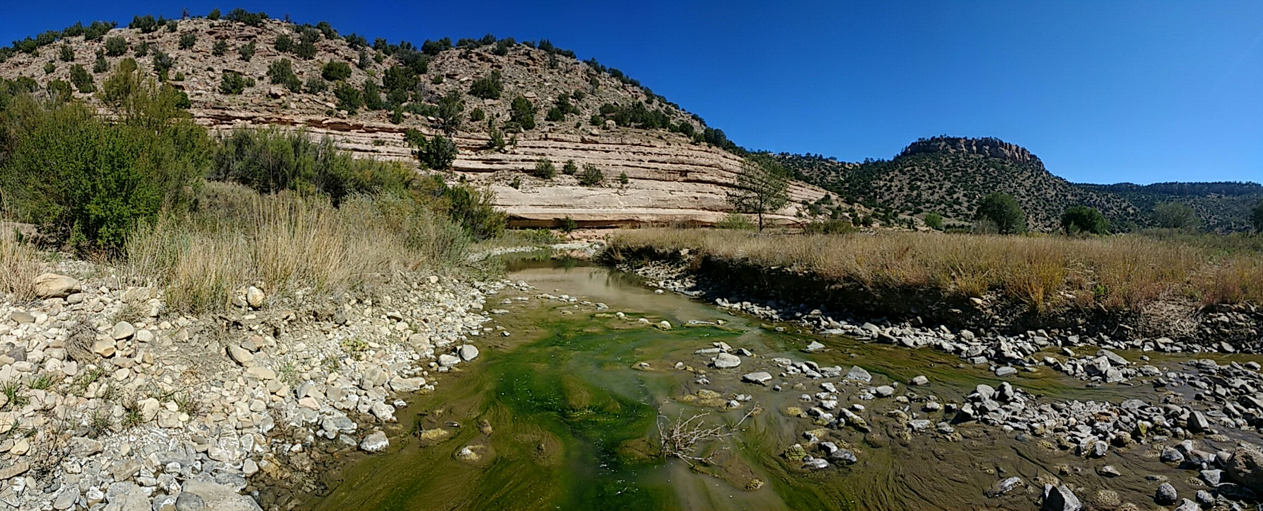

Canadian River west of Roy, NM at Rte 120. Photo Credit: NMED

# 5.0 Fish versus Macroinvertebrate Assemblage Comparison

A comparison was made between fish and BMI BCG levels for model prediction and expert rating results. The 18 valid NRSA validation samples were reviewed separately by the fish and BMI expert panels. Although there was no attempt to attain equal assessments for both assemblages, the experts reviewed the comparisons to determine whether there were any environmental, biological, or sampling factors that might contribute to unequal assessments.

Of the 18 valid NRSA samples with both fish and macroinvertebrate ratings, the model predicted comparable BCG levels for eight of them (**Table 19**). This counts ties as comparable to either the next higher or the next lower level. For six sites, the BMI model predicted better conditions than the fish model. For four sites, the fish model predicted better conditions than the BMI model.

Table . Comparison of predicted Biological Condition Gradient (BCG) levels between fish and BMI assemblages, showing expert ratings in cells where model comparisons were made. Blue text is the fish rating and green text is the macroinvertebrate rating. Blue cells indicate comparable ratings between assemblages. Pink cells indicate disagreements.

|  |  |  |  |  |  |  |  |  |  |  |  |
| --- | --- | --- | --- | --- | --- | --- | --- | --- | --- | --- | --- |
|  |  | Benthic Macroinvertebrates | | | | | | | | | |
|  | | 3- | 3-4 tie | 4+ | 4 | 4- | 4-5 tie | 5+ | 5 | 5-6 tie | 6 |
| Fish | 4 |  |  | 4+,4+ |  |  |  |  | 4, 5+ |  |  |
| 4- |  | 2* |  |  |  |  |  | 4-,4 |  |  |
| 5+ |  |  |  |  |  |  |  |  |  | 4-,5- |
| 5 | 5,3- | 5,3- |  | 4,4+ |  | 5+,4- | 5,4 | 2# | 5,4- | 5,6 |
| 5- |  |  |  |  |  |  |  |  |  |  |
| 6+ |  |  | 6+,34tie |  |  |  |  |  |  |  |
| 6 |  | 6+,3 |  | 5,4+ |  |  |  |  |  |  |

* 2 samples were predicted as BCG Level 4- for fish and a 3-4 tie for BMI. The expert rating for these samples were 4+ and 4- for fish and 3 for BMI.

# 2 samples were predicted as BCG Level 5 for both fish and BMI. The expert rating for these samples were 4-5 tie and 5 for both fish and BMI, respectively.

Differences occurred across the range of BCG levels. The differences were not always showing the same assemblage with better conditions. The split between better and worse conditions was almost even. This suggests that there was not a systematic or perception bias of the expert panels. However, of these 18 samples, none were identified as level 3 for fish, whereas one was identified as such for BMI and three more were predicted as 3-4 ties.

The greatest difference between model predictions was for a site predicted to be a BCG level 5 for fish and 3- for BMI (NRSA site FW08UT047, fish Samp7456 and BMI Samp9187). Experts compared the samples for this site and observed that the fish assemblage was dominated by non-native individuals (attributes 6 and 6t), which drove the fish rating lower (**Figure 15**). Very few non-native BMI were identified in the taxa lists and no non-native rule was described for BMI. The BMI assigned rating of 3 was based on number of taxa and a balanced trophic structure (**Figure 16**).

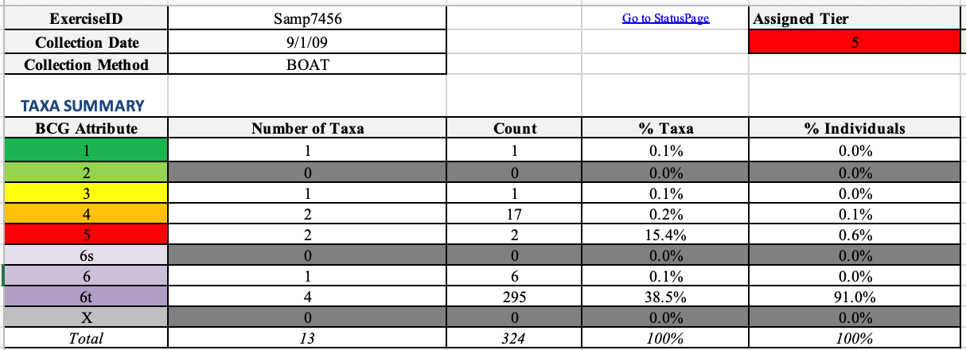

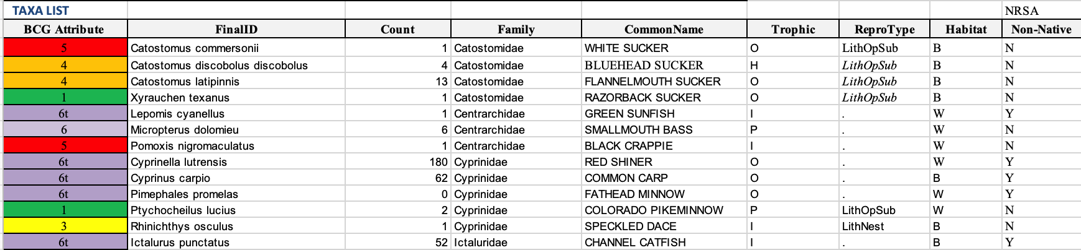



Figure . Fish data for site FW08UT047.



Figure . Macroinvertebrate data for site FW08UT047.

When considering another site (NRSA site FW08CA035, fish Samp7410 and BMI Samp9141) where the fish were rated 6+ and the BMI were rated a 3-4 tie, the experts observed again that the large percentage of non-native fish taxa and individuals drove the fish rating lower (**Figure 17**); whereas the BMI rating was based on the high number of taxa, sensitive taxa and a balanced trophic structure (**Figure 18**).





Figure . Fish data for site FW08CA035.



Figure . Macroinvertebrate data for site FW08CA035.

In an example (NRSA site FW08NE021) where the fish experts recognized better conditions (level 4-) than the BMI experts (level 5-), the experts observed that the fish assemblage was dominated by attribute III individuals and did not have any non-native taxa (**Figure 19**). However, the BMI density and diversity were very low (**Figure 20**). The expert ratings for these samples were somewhat better than the model predictions, but still disagreeing between assemblages; level 5+ for fish and level 6 for BMI.

|  |  |  |  |  |
| --- | --- | --- | --- | --- |
| **TAXA SUMMARY** | |  |  |  |
| **BCG Attribute** | **Number of Taxa** | **Count** | **% Taxa** | **% Individuals** |
| 1 | 0 | 0 | 0.0% | 0.0% |
| 2 | 0 | 0 | 0.0% | 0.0% |
| 3 | 1 | 37 | 12.5% | 52.9% |
| 4 | 3 | 23 | 37.5% | 32.9% |
| 5 | 2 | 3 | 25.0% | 4.3% |
| 6s | 0 | 0 | 0.0% | 0.0% |
| 6 | 0 | 0 | 0.0% | 0.0% |
| 6t | 0 | 0 | 0.0% | 0.0% |
| X | 2 | 7 | 25.0% | 10.0% |
| *Total* | *8* | *70* | *100%* | *100%* |

|  |  |  |  |  |
| --- | --- | --- | --- | --- |
| **BCG Attribute** | **FinalID** | **Count** | **Family** | **CommonName** |
| x | Unknown | 5 |  | UNKNOWN |
| 5 | Catostomus commersonii | 2 | Catostomidae | WHITE SUCKER |
| 5 | Cyprinella lutrensis | 1 | Cyprinidae | RED SHINER |
| 4 | Notropis blenniuis | 19 | Cyprinidae | RIVER SHINER |
| 4 | Platygobio gracilis | 1 | Cyprinidae | FLATHEAD CHUB |
| 3 | Rhinichthys cataractae | 37 | Cyprinidae | LONGNOSE DACE |
| x | Semotilus atromaculatus | 2 | Cyprinidae | CREEK CHUB |
| 4 | Fundulus sciadicus | 3 | Fundulidae | PLAINS TOPMINNOW |

|  |  |  |  |
| --- | --- | --- | --- |
| **Sample Metrics** |  | **Sample Metrics** |  |
| Percent Cyprinidae Individuals | 85.71 | Percent Herbivore Individuals | 0.00 |
| Number of Cyprinidae Taxa | 5.00 | Number of Herbivore Taxa | 0.00 |
| Percent Insectivore Individuals | 88.57 | Percent Lithophillic Individuals | 98.57 |
| Number of Insectivore Taxa | 5.00 | Number of Lithophillic Taxa | 7.00 |
| Percent Piscivore Individuals | 0.00 | Percent Water Column Individuals | 35.71 |
| Number of Piscivore Taxa | 0.00 | Number of Water Column Taxa | 4.00 |
| Percent Omnivore Individuals | 4.29 | Percent Benthic Individuals | 57.14 |
| Number of Omnivore Taxa | 2.00 | Number of Benthic Taxa | 3.00 |

Figure . Fish data for site FW08NE021.

|  |  |  |  |  |
| --- | --- | --- | --- | --- |
| **TAXA SUMMARY** | |  |  |  |
| **BCG Attribute** | **Number of Taxa** | **Count** | **% Taxa** | **% Individuals** |
| 1 | 0 | 0 | 0.0% | 0.0% |
| 2 | 0 | 0 | 0.0% | 0.0% |
| 3 | 1 | 8 | 20.0% | 38.1% |
| 4 | 3 | 6 | 60.0% | 28.6% |
| 5 | 0 | 0 | 0.0% | 0.0% |
| 6 | 0 | 0 | 0.0% | 0.0% |
| X | 1 | 7 | 20.0% | 33.3% |
| *Total* | *5* | *21* | *100%* | *100%* |
| **TAXA LIST** |  |  |  |  |
| **BCG Attribute** | **FinalID** | **Count** | **Excluded Taxa** | **Family** |
| 4 | *LYMNAEIDAE* | 1 | 0 | LYMNAEIDAE |
| x | *CAMBARIDAE* | 7 | 0 | CAMBARIDAE |
| 4 | *HYALELLA* | 1 | 0 | HYALELLIDAE |
| 3 | *ISONYCHIA* | 8 | 0 | ISONYCHIIDAE |
| 4 | *TRICORYTHODES* | 4 | 0 | LEPTOHYPHIDAE |
|  | **TOTAL** | **21** |  |  |

|  |  |  |  |
| --- | --- | --- | --- |
| **Sample Metrics** |  | **Sample Metrics** |  |
| Shannon Diversity Index | 1.93 | Odonata percent individuals | 0.00 |
| Percent of target subsample attained | 7.00 | Collector percent individuals | 57.14 |
| EPT taxa | 2 | Filterer percent individuals | 38.10 |
| Trichop taxa, except Hydropsychidae | 0 | Predator percent individuals | 0.00 |
| Chironomidae taxa | 0 | Scraper percent individuals | 4.76 |
| Number native Mollusca | 1 | Shredder percent individuals | 0.00 |
| EPT percent individuals | 57.14 | Maximum percentage for any FFG | 57 |
| Non-insects percent individuals | 42.86 | Predator taxa | 0 |
| Chironomidae percent individuals | 0.00 | Scraper taxa | 1 |
| Coleoptera percent individuals | 0.00 | Shredder taxa | 0 |
| Ephemeroptera percent individuals | 57.14 | Clinger taxa | 0 |

Figure . Macroinvertebrate data for site FW08NE021.

The experts proposed several reasons that one assemblage might receive a better BCG score than the other assemblage. Different responses might result from different sensitivities of the assemblages to different stressors and sampling effort. For example, fish tend to be more sensitive to physical habitat structure and connectivity, whereas BMI tend to be more sensitive to water quality and bottom substrates.

*Water quality impacts*. The biotic response is dependent upon whether the pollution is chronic or acute.

* In the case of acute exposure, the benthic macroinvertebrate assemblage can recover much more quickly than the fish; the BMI can often come back in a few days by flying in from nearby unaffected areas or adjacent watersheds, but fish have to recolonize from within the same watershed. If no nearby tributaries exist as a supply of source fish for recolonizing, fish may have to swim from long distances away to recolonize (depending upon the extent of area affected by the acute exposure).
* The fish assemblage generally gives a longer temporal perspective than the BMI of what is going on in the system.
* Chronic low dissolved oxygen and high temperatures might affect fish more than BMI and could be one reason that one would not find any fish at a site.
* BMI might be more sensitive to sedimentation and land-use change.

*Water quantity and flow*. High flow events affect the assemblages differently.

* Long-lived native large-bodied fish require deep flowing water; some require overbanking flows to successfully spawn in flooded backwater areas.
* Pelagic broadcast spawners require specific flow, duration, and timing for their broadcasted eggs to be carried in the current while they develop.
* The substantially altered flow regimes of southwestern U.S. rivers may alter fish assemblages more than BMI assemblages because of the larger ranges and life history requirements of fish.
* BMI can be washed out of a site for a few days after a high flow event (e.g., a dam release).

*Physical habitat structure*. Channel, riparian and floodplain complexity likely affect fish and BMI assemblages differently

* The substantially altered physical habitat structure of sandy-bottom southwestern U.S. river channels, riparian zones, and floodplains may alter fish assemblages more than BMI assemblages because of their differing habitat and life history requirements.

*Historical data on species*.

* The Sublette dataset provided a historical assemblage of fish species. Many of these species were not collected as part of the NRSA dataset that was used in this exercise.
* Native fish distributions are fairly well established allowing the inclusion of a non-native species rule. This rule often drove the fish BCG rating lower.
* There is very little data on BMI prior to the 1970s, so it is difficult to determine which BMI are native, therefore no comparable non-native rule was established for BMI.

*Sampling effort*.

* Sampling methods underestimate true taxa richness of a river reach (Hughes et al. 2002 and 2012, Flotemersch et al. 2011, Cao et al. 2002).
* Although sampling effort for both fish and BMI was consistent across samples for each assemblage, neither collection protocol produced all the expected taxa—especially for BMI and rare fish species.

# 6.0 Discussion

The validations of the BMI and fish models indicate that the models are applicable in perennial sandy-bottom rivers throughout southwestern U.S. Any results from such an application should be qualified with a statement that the model might predict a biological condition that is one level different than would be recognized by a panel of experts in approximately 1.5 out of 10 cases. In the regional validation data, the model always predicted a level worse than the experts when there were disagreements. For calibration data the model was biased towards predictions worse than the expert ratings, but not consistently so.

The experts observed several factors that might affect the differences in sample interpretations relative to model predictions. In one of the BMI model disagreements, the rule regarding number of taxa caused a model prediction of BCG level 6 though the experts generally recognized the sample as Level 5. Apparently, taxa richness <5-15 taxa was not an immediate disqualifier for level 5 conditions during expert review. The experts did not recommend adjusting this model rule.

The number of BMI taxa is related to the number of individuals in the sample. For the NRSA samples, 11 transects were sampled for macroinvertebrates and a composite sample was processed with a target of a 300-organism subsample. For this level of effort, most samples should be able to attain the target number of individuals and a minimal number of taxa. Some experts were unfamiliar with the NRSA sampling methods and might have excused low numbers of individuals and taxa, attributing that difference to the difficulty in sampling in general. Those experts that were familiar with the NRSA sampling methodology, admitted low numbers of individuals and taxa might be expected in rivers with shifting sandy substrates. For example, Li et al. (2014) reported that the total numbers of BMI and chironomid taxa in sand-bottom Chinese streams did not reach asymptotes until well after the 11 subsamples employed in NRSA sampling. Silva et al. (2016) reported the same shortcoming for family and EPT genera richness in sand-bottom Brazilian streams. At levels 2, 3, and 4, there is a rule requiring 50% of the target subsample size. Metrics calculated on samples with low numbers of individuals can be unreliable because a few individuals can have great effects on the percentages of certain taxa groups. In addition, the NRSA wadeable river method includes center-channel samples in one-third of the transects, compared to the boatable method that samples in the littoral zone at all transects. This difference might introduce a bias towards lower productivity in the wadeable samples.

Other BMI rules that appeared to contribute to model disagreements were discussed, but no changes were recommended. The rule requiring < 15-25% non-insect taxa was possibly too restrictive at level 4, although it was considered appropriate at levels 2 and 3. The rule requiring <70-80% dominance of any one functional feeding group might interact with the percentage of non-insects. The experts suggested that the rule might be appropriate if applied only among insect taxa, but no model revisions were implemented.

The fish experts were skeptical of the native status assigned to taxa in some NRSA samples. The native status for all species was derived from fish distribution maps relative to site locations. However, the experts had knowledge and experience that refuted some of the NRSA designations. Those changes in native status were applied before final model application and rating.

## Summary and Recommendations for Future Research

Although the BCG calibration and model development process has been described for other waterbodies (Jessup and Gerritsen 2014; Gerritsen and Jessup 2007; Stamp and Gerritsen 2011; Danielson et al. 2012; Stamp et al. 2014; Gerritsen et al. 2012; Gerritsen and Leppo 2005; Paul et al. 2020; Charles et al. 2019; Hausmann et al. 2016; Stamp and Gerritsen 2019; Gerritsen et al. 2017; Shumchenia et al. 2015; Bouchard et al. 2016), this is its first application in southwestern U.S. rivers. The experts used bioassessment data combined with personal knowledge to develop quantitative decision rules to describe six levels of river ecosystem condition through an iterative process. The BCG levels are biologically recognizable, measurable stages in river condition in response to increasing anthropogenic stress. The fish BCG model replicated the expert consensus in 87% to 84% (validation and calibration, respectively). The BMI BCG model replicated the expert consensus in 93% and 83% (calibration and validation, respectively).

Several research questions arose during development of the southwestern U.S. rivers BCG that could be areas for future research.

1. *BCG attribute assignments*. Were attributes calibrated properly for large rivers, or did the experts’ stream-centric assessment biases creep in to attribute assignments? For example: is it appropriate to expect organisms that require cold, well-oxygenated water to be present in large rivers? If not, then those typically “sensitive” taxa might only indicate some anomalies? Additionally, there may be some “river-sensitive” taxa that were not considered; especially some that are sensitive to habitat conditions. The lack of sensitive taxa in the BMI taxa list reduces the responsiveness to attribute-based metrics.
2. *Expectations for best current conditions*. Are BCG level 2 samples possible, given the grand scale of modifications and insults in southwestern U.S. sandy-bottom rivers? Standard level 2 definitions include the description that *virtually all native taxa are maintained, and ecosystem functions are fully maintained.* This is difficult to determine because there were no available historic data from undisturbed systems for the BMI that the experts could assess to fully understand what native taxa and functions should exist. For fish, the Sublette dataset provided historical species presence data that supported the conceptual rules for level 2. Additionally, level 2 definitions include the stipulation that *there may be some reduction of a small fraction of highly sensitive or specialized taxa (Attribute II) or loss of some endemic or rare taxa*. The BMI experts assigned very few taxa to the specialized Attribute II category, their absence could be perceived as a loss, but presence was virtually undetectable in any samples.
3. *BMI observations fell mainly in the BCG levels 3 and 4.* Are macroinvertebrates so resilient that they are able to quickly overcome temporary disturbance events? Perhaps BCG level 5s are uncommon because the BMI assemblage is resilient and tolerant of hydrological variability. Furthermore, the lack of level 6 assignments may be because dry rivers are not sampled and tabulated.
4. *Chironomids*. Chironomid dominance was generally indicative of poor biological condition. However, if the dominant chironomids are represented by diverse taxa, then poor conditions are not indicated. This was one of the observations that was related to sandy-bottom river systems, in which chironomids are expected to thrive, but if they dominate other groups of organisms, they should also be diverse.
5. *Sublette dataset for fish*. The digitized data for the Sublette dataset only provided presence/absence information. If the original field records were fully digitized and counts were also available, a more complete understanding of BCG level 2, and possibly BCG level 1 could be developed.
6. *Texas Rio Grande application of the fish BCG Model*. A separate analysis of the Texas Rio Grande fish data within Ecoregion 24 showed that the fish BCG model responded to the contribution of the Rio Conchos which sustains flow in the Rio Grande from its confluence with it (all but one of the sites downstream of the confluence, until Del Rio, rated as a 4).  Upstream of the Rio Conchos, the river often goes dry (all these sites received a BCG rating of 5).  Attribute assignments for some species were revised because they were native to the Texas reach and there were a number of species in the Texas reach that were not present in New Mexico that required attribute assignments. This application demonstrates the importance of water quantity and flow regime for fish assemblages, which should be more fully explored and documented.
7. *Application of the BCG rules to the full NRSA dataset*. The model was validated with a small sample of NRSA river data. More detail could be put towards comparing BCG model results and NRSA index assessment results, including expert input in a larger sample. Preliminary analysis towards this end shows a broad agreement of BCG levels with NRSA assessment results. In addition, there were similar patterns of bias among the two biological assemblages seen in the larger data set as were seen in the validation data set.

Because fish and BMI assemblages respond differently to stressors, including both in bioassessments can provide for a robust assessment of biological condition. The BMI and fish models regularly predicted the same BCG levels assigned by the experts. Application as an assessment tool could be considered in New Mexico and other southwestern states. The BCG can support regulatory and non-regulatory water quality and conservation programs, including development of biocriteria. Numeric biocriteria coupled with biologically based aquatic life uses provide a direct measure of the aquatic resource that is being protected (e.g., sandy-bottom southwestern U.S. rivers), and complement chemical, physical, and water quality criteria. Examples of how the BCG models can be used to support existing riverine management programs is shown in **Table 20**.

Table **.** Application of the Biological Condition Gradient (BCG) for existing riverine management.

| **Management Area** | **Description** | **Application of the BCG** |
| --- | --- | --- |
| Water quality protection | Establish biologically-based aquatic life criteria for sandy-bottom southwestern U.S. rivers | * Provide the legally defensible means to translate scientific understanding into legal and regulatory authority |
| Establish biocriteria for sandy-bottom southwestern U.S. rivers | * Establish scientifically defensible thresholds of biological condition against which to measure detrimental effects on biological assemblages. |
| CWA 305(b) and 303(d) impaired waters reporting | * Provide the scientific rationale and thresholds for attainment of designated aquatic life uses |
| Effluents | 301(h) effluent limitation waivers to defer secondary treatment if discharge does not adversely affect biological assemblages. | * Providing a threshold against which to measure detrimental effects on biological assemblages. |
| 319 Nonpoint Source Program (NPS) | Every five years, states report to EPA on their NPS pollution problems, including categories of NPS pollution and measures used to reduce that pollution. | * Assessing impacts of NPS pollution. * Determining effectiveness of NPS controls. * Site-specific assessment of BMPs for NPS. |
| National Pollutant Discharge Elimination System (NPDES) | The CWA makes it illegal to discharge pollutants from a point source to the waters of the United States. Point sources must obtain a discharge permit from the proper authority (usually a state, sometimes EPA, a tribe, or a territory). The permits set the limit on the amounts of various pollutants that a given source can discharge in a given time. | * Determining condition of a waterbody prior to issuance of a permit. * Providing a threshold against which to measure discharger impacts on biological assemblages. * Evaluating effectiveness of implemented controls. * Helping to verify that NPDES permit limits are resulting in achievement of state water quality standard. |
| Clean Water State Revolving Fund (CWSRF) | Authorizes annual capitalization grants to states who in turn provide low interest loans for a wide variety of water quality projects. | * To provide a threshold to measure the degree to which water quality projects reduce human impacts on biological assemblages. |
| Managing Fisheries | Establish sustainable fisheries regulations | * To establish levels (e.g., taxa richness, abundance) expected to sustain fisheries * Degradation can trigger changes in fishery practices and regulations |
| Restricting the species being selected | * To establish expected or desired levels of individual species (e.g., abundance, biomass) * Degradation can trigger changes in fishery practices and regulations |
| Watershed Management | Developing and implementing watershed management plans | * To support setting goals for watershed and regional planning * To prioritize watershed goals and actions * To establish thresholds against which to measure effectiveness of permits or other management actions |
| Managing Endangered Species (Endangered Species Act) | Protecting rare, threatened, and endangered species | * To establish expected or desired levels of individual species (e.g., abundance, biomass). * To establish thresholds against which to measure effectiveness of legal protection. * For example, the Rio Grande Silvery Minnow |
| National Environmental Policy Act (NEPA) of 1969 | Environmental Impact Statements | * To identify where site-specific criteria modifications may be needed to effectively protect a waterbody. * To assess the overall ecological effects of regulatory actions. |
| Flow Regime Management | Developing Flow Regime Management Plans | * Assess results of flow naturalization |
| Fish Passage | Install Upstream & Downstream Fish Passes | * Assess results of fish passes |
| Channel, Riparian & Floodplain  Rehabilitation/Naturalization | Rehabilitate Channel, Riparian Zone & Floodplain | * Assess results of rehabilitation projects |

# 7.0 Literature Cited

33 USC §1251 et seq. 1972. *Federal Water Pollution Control Amendments of 1972* (aka The Clean Water Act).

Allan DJ, Abell R, Hogan Z, Revenga C, Taylor BW, Welcomme RL and Winemiller K. 2005. Overfishing of inland waters. *Bioscience* **55**: 1041–1051.

Angradi TR. 1999. Fine sediment and macroinvertebrate assemblages in Appalachian streams: a field experiment with biomonitoring applications. *Journal of the North American Benthological Society* **18(1)**: 49-66.

Archdeacon TP, Davenport SR, Grant JD and Henry EB. 2018. Mass upstream dispersal of pelagic-broadcast spawning cyprinids in the Rio Grande and Pecos River, New Mexico, *Western North American Naturalist* **78(1)**: 100-105.

Archdeacon TP, Henderson KR, Austring TJ and Cook RL. 2015. Comparison of fish communities at random and nonrandom locations in a sand-bed river. *North American Journal of Fisheries Management* **35**: 578–585.

Barbour MT, Gerritsen J, Snyder BD and Stribling JB. 1999. *Rapid Bioassessment Protocols for Use in Streams and Wadeable Rivers: Periphyton, Benthic Macroinvertebrates and Fish, Second Edition*. EPA 841-B-99-002. U.S. Environmental Protection Agency; Office of Water; Washington, D.C.

Bazzanti M, 1991. Sandy bottom macroinvertebrates in two moderately polluted stations of the River Treia (Central Italy): structural and functional organization. In *Annales de Limnologie-International Journal of Limnology* 27(3): 287-298. EDP Sciences.

Bazzanti M, 2000. Ecological requirements of chironomids (Diptera: Chironomidae) on the soft bottom of the River Arrone, Central Italy. *Journal of Freshwater Ecology*, 15(3): 397-409.

Benejam L, Ordeix M, Casals F, Caiola N, de Sostoa A, Solà C and Munné A, 2015. Fish as ecological indicators in Mediterranean streams: the Catalan experience. In *Experiences from Surface Water Quality Monitoring* (pp. 101-123). The Handbook of Environmental Chemistry, vol 42. Springer, Cham.

Bestgen K and Platania S. 1991. Status and Conservation of the Rio Grande Silvery Minnow, *Hybognathus amarus*. *The Southwestern Naturalist* **36(2):** 225-232.

Bouchard RW, Niemela S, Genet JA, Yoder CO, Sandberg J, Chirhart JW, Feist M, Lundeen B and Helwig D. 2016. A novel approach for the development of tiered use biological criteria for rivers and streams in an ecologically diverse landscape. *Environmental Monitoring and Assessment* **188(3)**:196.

Bradley P, Santavy DL and Gerritsen J. 2014. *Workshop on biological integrity of coral reefs, August 21–22, 2012*, Caribbean Coral Reef Institute, Isla Magueyes, La Parguera, Puerto Rico. U.S. EPA, ORD, AED, Narragansett, RI. EPA/600/R-13/350.

Bradley P, Jessup B, Gerritsen J and Gallindo A. 2016. *The coral reef biological condition gradient: moving toward quantitative criteria from species-based attributes*. TetraTech, Inc. Prepared for the U.S. Environmental Protection Agency, Office of Water, Office of Science and Technology, Washington, D.C.

Bradley P. Jessup B., Pittman SJ, Jeffrey CFG, Ault JS, Carrubba L, Lilyestrom C, Appeldoorn RS, Schärer MT, Walker BK and McField M. 2020. Development of a reef fish biological condition gradient model with quantitative decision rules for the protection and restoration of coral reef ecosystems. *Marine Pollution Bulletin* **159**: .111387.

Brown JH and Gillooly JF. 2003. Ecological food webs: high-quality data facilitate theoretical unification. *Proceedings of the National Academy of Sciences* **100**: 1467–1468.

Camargo JA, Alonso A and De La Puente M. 2004. Multimetric assessment of nutrient enrichment in impounded rivers based on benthic macroinvertebrates. *Environmental Monitoring and Assessment* **96:** 233-249.

Carlisle DM and Clements WH. 1999. Sensitivity and variability of metrics used in biological assessments of running waters. *Environmental Toxicology and Chemistry* **18**: 285-291.

Cao, Y., D.P. Larsen, R.M. Hughes, P.L. Angermeier, and T.M. Patton. 2002. Sampling effort affects multivariate comparisons of stream communities. *Journal of the North American Benthological Society* 21:701-714.

Casal CMV. 2006. Global documentation of fish introductions: the growing crisis and recommendations for action. *Biological Invasions* **8:** 3–11.

Charles DF, Tuccillo AP and Belton TJ. 2019. Use of diatoms for developing nutrient criteria for rivers and streams: a biological condition gradient approach. *Ecological Indicators* **96:** 258-269.

Clement TA, Murry BA and Uzarski DG. 2015. Fish community size structure of small lakes: the role of lake size, biodiversity and disturbance. *Journal of Freshwater Ecology* **30(4)**: 557-568.

Close PG, Dobbs RJ, Tunbridge DJ, Speldewinde PC, Warfe DM, Toussaint S and Davies PM. 2014. Customary and recreational fishing pressure: large-bodied fish assemblages in a tropical, intermittent Australian river. *Marine and Freshwater Research* **65**: 466–474.

Cowley DE, Shirey PD and Hatch MD. 2006. Ecology of the Rio Grande Silvery Minnow (Cyprinidae: *Hybognathus amarus****)***inferred from specimens collected in1874.  *Reviews in Fisheries Science* **14(1-2)**: 111-125.

Cowley DE. 2002. Water requirements for endangered species – Rio Grande Silvery Minnow (*Hybognathus amarus). Proceedings of the 47th Annual New Mexico Water Conference.*

Cowley DE, Wissmar RC, and Sallenave R. 2007. Fish assemblages and seasonal movements of fish in irrigation canals and river reaches of the middle Rio Grande, New Mexico (U.S.A.). *Ecology of Freshwater Fish* **16**:548-558.

Cucherousset J and Olden JD. 2011. Ecological impacts of non-native freshwater fishes. *Fisheries* **36(5):** 215-230.

Danielson TJ, Loftin CS, Tsomides L, DiFranco JL, Connors B, Courtemanch DL, Drummond F and Davies SP. 2012. An algal model for predicting attainment of tiered biological criteria of Maine’s streams and rivers. *Freshwater Science* **31(2)**: 318–340.

Davies SP and Jackson SK. 2006. The biological condition gradient: a descriptive model for interpreting change in aquatic ecosystems. *Ecological Applications* **16(4)**: 1251-1266.

Droesen WJ. 1996. Formalisation of ecohydrological expert knowledge applying fuzzy techniques. *Ecological Modelling* 85(1): 75-81.

Dudley RK and Platania SP. 1997. *Habitat Use of Rio Grande Silvery Minnow*. Report submitted to New Mexico Department of Game and Fish and United States Bureau of Reclamation. 96 pp.

Duffy JE. 2002. Biodiversity and ecosystem function: the consumer connection. *Oikos* **99**: 201–219.

Finch DM and Tainter JA. 1995. *Ecology, diversity, and sustainability of the Middle Rio Grande Basin.* Diane Publishing. Darby, PA.

Flotemersch JE, Stribling JB, Hughes RM, Reynolds L, Paul MJ, and Wolter C. 2011. Site length for biological assessment of boatable rivers. *River Research & Applications* 27:520-535.

Galiana N, Lurgi M, Montoya JM and López BC. 2014. Invasions cause biodiversity loss and community simplification in vertebrate food webs. *Oikos* 123: 721-728.

Gerritsen J, Leppo EW, Zheng L, and Yoder CO. 2012. *Calibration of the biological condition gradient for streams of Minnesota*. Prepared for Minnesota Pollution Control Agency, St. Paul, MN. Prepared by Tetra Tech, Owings Mills, MD.

Gerritsen J, Bouchard Jr RW, Zheng L, Leppo EW and Yoder CO. 2017. Calibration of the biological condition gradient in Minnesota streams: a quantitative expert-based decision system. *Freshwater Science* ***36*(2**): 427-451.

Gerritsen J and Jessup B. 2007. *Calibration of the biological condition gradient for high-gradient streams of Connecticut*. Report prepared for U.S. EPA Office of Science and Technology and the Connecticut Department of Environmental Protection. Prepared by Tetra Tech, Owings Mills, MD.

Gerritsen J and Leppo EW. 2005. *Biological condition gradient for tiered aquatic life use in New Jersey*. Prepared for U.S. EPA Office of Science and Technology. Prepared by Tetra Tech, Owings Mills, MD. 400 pp.

Gerritsen J and Stamp J. 2014. *Biological Condition Gradient (BCG) Assessment Models for Lake Fish Communities of Minnesota*. Prepared for the Minnesota Pollution Control Agency and the Minnesota Department of Natural Resources. Prepared by Tetra Tech, Owings Mills, MD.

Goldstein RM and Meador MR. 2004. Comparison of fish species traits from small streams to large rivers. *Transactions of the American Fisheries Society* **133:** 971–983.

Green A, Smith SE, Lipsett-Moore G, Groves C, Peterson N, Sheppard S, Lokani P, Hamilton R, Almany J, Aitsi J and Bualia L. 2009. Designing a resilient network of marine protected areas for Kimbe Bay, Papua New Guinea. *Fauna & Flora International, Oryx* **43(4):** 488–498.

Hausmann, S, Charles DF, Gerritsen J and Belton TJ. 2016. A diatom-based biological condition gradient (BCG) approach for assessing impairment and developing nutrient criteria for streams. *Science of the Total Environment* **562**: 914-927.

Herlihy, A.T., J.C. Sifneos, R.M. Hughes, D.V. Peck, and R.M. Mitchell. 2020. Relation of lotic fish and benthic macroinvertebrate condition indices to environmental factors across the conterminous USA. *Ecological Indicators* 112 (May):105958.

Higgins CL. 2009. Spatiotemporal variation in functional and taxonomic organization of stream-fish assemblages in central Texas. *Aquatic Ecology* **43**: 1133–1141.

Hoagstrom C and Turner TF. 2013. Recruitment ecology of pelagic-broadcast spawning minnows: paradigms from the ocean advance science and conservation of an imperilled freshwater fauna. *Fish and Fisheries* **16(2)**: 282-299.

Hoagstrom CW, Zymonas ND, Davenport SR, Propst DL and Brooks JE. 2010. Rapid species replacements between fishes of the North American plains: a case history from the Pecos River. *Aquatic Invasions* **5**: 141–153.

Horan DL, Kershner JL, Hawkins CP and Crowl TA. 2000. Effects of habitat area and complexity on Colorado River cutthroat trout density in Uinta Mountain streams. *Transactions of the American Fisheries Society* **129**(6): 1250-1263.

Hughes RM, Larsen DP and Omernik JM. 1986. Regional reference sites: a method for assessing stream potentials. *Environmental Management* **10**: 629-635.

Hughes RM, Kaufmann PR, Herlihy AT, Intelmann SS, Corbett SC, Arbogast MC, and Hjort RC. 2002. Electrofishing distance needed to estimate fish species richness in raftable Oregon rivers. *North American Journal of Fisheries Management* **22**:1229-1240.

Hughes SJ, Santos JM, Ferreira MT, Carac ̧a R, Mendes AM. 2009. Ecological assessment of an intermittent Mediterranean river using community structure and function: evaluating the role of different organism groups. *Freshwater Biology* **54**: 2383–2400.

Hughes RM, Herlihy AT, Gerth WJ, and Pan Y. 2012. Estimating vertebrate, benthic macroinvertebrate and diatom taxa richness in raftable Pacific Northwest rivers for bioassessment purposes. *Environmental Monitoring & Assessment* **184**:3185-3198.

Humphries P and Winemiller KO. 2009. Historical impacts on river fauna, shifting baselines, and challenges for restoration. *Bioscience* **59**: 673–684.

Hutchens Jr JJ, Schuldt JA, Richards C, Johnson LB, Host GE and Breneman DH. 2009. Multi-scale mechanistic indicators of Midwestern USA stream macroinvertebrates. *Ecological Indicators* **9(6)**: 1138-1150.

Jacobi GZ, Jacobi MD, Barbour MT and Leppo EW. 2006. *Benthic macroinvertebrate stream condition indices for New Mexico wadeable streams.* Prepared for the New Mexico Environment Department, Santa Fe, NM. Prepared by Tetra Tech, Owings Mills, MD.

Jessup BK and Gerritsen J. 2014. *Calibration of the Biological Condition Gradient (BCG) for Fish and Benthic Macroinvertebrate Assemblages in Northern Alabama*. Prepared for Alabama Department of Environmental Management, Montgomery, AL. Prepared by Tetra Tech, Owings Mills, MD.

Jessup B and Pappani J. 2015. Combination of biological and habitat indices for assessment of Idaho streams. *Journal of the American Water Resources Association* **51(5):** 1408-1417.

Jones GP, Almany GR, Russ GR, Sale PP, Steneck RS, van Oppen JH and Willis BL. 2009. Larval retention and connectivity among populations of corals and reef fishes: history, advances and challenges. *Coral Reefs* **28**: 307–325.

Karr JR and Chu EW. 1999. *Restoring Life in Running Waters; Better Biological Monitoring*. Island Press, Washington, D.C. 206 pp.

Karr JR and Dudley DR. 1981. Ecological perspectives on water quality goals. *Environmental Management* **5:** 55-58.

Karr JR, Toth LA and Dudley DR. 1985. Fish communities of mid-western rivers: a history of degradation. *Bioscience* **35(2):** 90-95.

Karr JR. 1981. Assessment of biotic integrity using fish communities. *Fisheries* **6:** 21–27.

Karr JR, Fausch KD, Angermeier PL, Yant PR and Schlosser IJ. 1986. Assessing biological integrity in running waters. A method and its rationale. *Illinois Natural History Survey*, Champaign, Special Publication, 5.

Kerr SR and Dickie LM. 2001. *The Biomass Spectrum: A Predator-Prey Theory of Aquatic Production*. Columbia University Press. 253 pp.

Kopf RK, Finlayson CM, Humphries P, Sims NC and Hladyz S. 2015. Anthropocene baselines: assessing change and managing biodiversity in human-dominated aquatic ecosystems. *BioScience* **65:** 798–811.

Kramer DL and Chapman MR. 1999. Implications of fish home range size and relocation for marine reserve function. *Environmental Biology of Fishes*, 55(1-2), pp.65-79.

Lammert M and Allan JD. 1999. Assessing biotic integrity of streams: effects of scale in measuring the influence of land use/cover and habitat structure on fish and macroinvertebrates. *Environmental Management* **23(2)**: 257-270.

Lawrence JM and Gresens SE. 2004. Foodweb response to nutrient enrichment in rural and urban streams. *Journal of Freshwater Ecology* **19:** 375 - 385.

Li L, Liu L, Hughes RM, Cao Y, and Wang X. 2014. Towards a protocol for stream macroinvertebrate sampling in China. *Environmental Monitoring & Assessment*. 186:469-479.

Linam GW, Kleinsasser LJ and Mayes KB. 2002. *Regionalization of the index of biotic integrity for Texas streams. River Studies Report No. 17*. Resource Protection Division, Texas Parks and Wildlife Department, Austin, TX. 140 pp.

McCune B and Mefford MJ. 2016. *PC-ORD. Multivariate Analysis of Ecological Data. Version 7.06*. MjM Software, Gleneden Beach, Oregon, U.S.A.

Morris L, Stuever M, Ellis L and Tydings R (eds). 2003. *Bosque Education Guide, second edition*. Friends of the Rio Grande Nature Center. Albuquerque, NM. 22 pp.

Moyle PB and Nichols RD. 1973. Ecology of some native and introduced fishes of the Sierra Nevada foothills in central California. *Copeia*, pp.478-490.

Nelson JS. 1994. *Fishes of the World*. Wiley: New York.

New Mexico Environment Department Surface Water Quality Bureau (NMED/SWQB). 2013. *Standard Operating Procedure for Fish Community Sampling***.** SOP 11.4, Effective Date: 04/03/2013.

Nyström M and Folke, C. 2001. Spatial resilience of coral reefs. *Ecosystems*, *4*(5), pp.406-417.

Odum EP. 1985. Trends expected in stressed ecosystems. *BioScience* **35:** 419–422.

Paul MJ, Jessup B, Brown LR, Carter JL, Cantonati M, Charles DF, Gerritsen J, Herbst DB, Stancheva R, Howard J and Isham B. 2020. Characterizing benthic macroinvertebrate and algal biological condition gradient models for California wadeable Streams, USA. *Ecological Indicators* **117:** 106618.

Paul MJ, Meyer JL and Couch CA. 2006. Leaf breakdown in stream differing in catchment land use. *Freshwater Biology* **51**: 1684-1695.

Pauly D. 1995. Anecdotes and the shifting baseline syndrome of fisheries. Trends in Ecology and Evolution **10(10):** 430.

Poff NL and Allan JD. 1995. Functional organization of stream fish assemblages in relation to hydrological variability. *Ecology* **76:** 606–627.

Rabeni CF, Doisy KE and Zweig LD. 2005. Stream invertebrate community functional responses to deposited sediment. *Aquatic Sciences* **6**: 395-402.

Rapport DJ and Whitford WG. 1999. How ecosystems respond to stress: common properties of arid and aquatic systems. *BioScience* **49(3)**:193-203.

Reiss JO. 1989. The meaning of developmental time: a metric for comparative embryology. *The American Naturalist* **134(2)**: 170-189.

Rinne JN and Platania SP. 1994. *Fish fauna of the Middle Rio Grande: status, threats and research needs*. Accessed 10/12/2020 at URL: http://www.nativefishlab.net/library/textpdf/15005.pdf

Rinne JN, Hughes RM, and Calamusso B, editors. 2005. *Historical changes in large river fish assemblages of the Americas*. American Fisheries Society, Symposium 45, Bethesda, MD.

Sallenave R, Carrasco C and Cowley DE. 2010. *Fishes in the Middle and Lower Rio Grande Irrigation Systems of New Mexico*. **Circular 653, College of Agricultural, Consumer and Environmental Sciences, New Mexico State University.**

Santavy DL, Bradley P, Gerritsen J and Oliver L. 2016. The Biological Condition Gradient, a Tool used for Describing the Condition of US Coral Reef Ecosystems. *Proceedings of the 13th International Coral Reef Symposium* 557-568.

Schlosser IJ. 1982. Fish community structure and function along two habitat gradients in a headwater stream. *Ecological Monographs* **52:** 395–414.

Shumchenia EJ, Pelletier MC, Cicchetti G, Davies S, Pesch CE, Deacutis CF and Pryor M. 2015. A biological condition gradient model for historical assessment of estuarine habitat structure. *Environmental Management* ***55*(1)**: 143-158.

Silva D, Ligeiro R, Hughes RM, and Callisto M. 2016. The role of physical habitat and sampling effort on estimates of benthic macroinvertebrate taxonomic richness at basin and site scales. *Environmental Monitoring & Assessment* 188:340. doi:10.1007/s10661-016-5326-z

Stamp J and Gerritsen J. 2011. *A Biological Condition Gradient (BCG) Assessment Model for Stream Fish Communities of Connecticut*. Prepared for USEPA Office of Science and Technology and Connecticut DEEP. Prepared by Tetra Tech, Owings Mills, MD.

Stamp J and Gerritsen J. 2019. *Calibration of the Biological Condition Gradient (BCG) for Macroinvertebrate Assemblages in Puget Lowland/Willamette Valley Freshwater Wadeable Streams*. Report prepared for U.S. EPA Office of Water, Office of Science and Technology. Prepared by Tetra Tech, Owings Mills, MD.

Stamp J, Gerritsen J, Pond G, Jackson SK and Van Ness K. 2014. *Calibration of the Biological Condition Gradient (BCG) for Fish and Benthic Macroinvertebrate Assemblages in the Northern Piedmont region of Maryland*. Prepared for US EPA Office of Water, Office of Science and Technology. Prepared by Tetra Tech, Owings Mills, MD.

Stoddard JL, Larsen DP, Hawkins CP, Johnson RK, and Norris RH. 2006. Setting expectations for the ecological condition of streams: the concept of reference condition. *Ecological applications*, *16*(4), pp.1267-1276.

Sublette JE, Hatch MD and Sublette M. 1990. *The fishes of New Mexico*. New Mexico Department of Game and Fish. 389 pp.

Tetra Tech. Unpublished report. *Development of a fish database and index of biological integrity (F-IBI)*. Prepared for New Mexico Environment Department, Surface Water Quality Bureau. Prepared by Tetra Tech, Santa Fe, NM. Prepared by Tetra Tech, Owings Mills, MD.

U.S. Environmental Protection Agency (EPA). 1990. *Biological Criteria: National Program for Surface Waters*. U.S. Environmental Protection Agency, Office of Water, Washington, DC. EPA-440/5-90-004.

U.S. Environmental Protection Agency (EPA). 2002. *Biological Assessments and Criteria: Crucial Components of Water Quality Programs*. U.S. Environmental Protection Agency, Office of Water, Washington, DC. EPA-822-F-02-006.

U.S. Environmental Protection Agency (EPA). 2011. *A Primer on Using Biological Assessments to Support Water Quality Management*. U.S. Environmental Protection Agency, Washington DC. EPA 810-R-11-01.

U.S. Environmental Protection Agency (EPA). 2016. *A Practitioner’s Guide to the Biological Condition Gradient: A Framework to Describe Incremental Change in Aquatic Ecosystems*. U.S. Environmental Protection Agency, Washington DC. EPA 842-R-16-001.

U.S. Environmental Protection Agency (EPA). 2017. *National Rivers and Streams Assessment 2018/19: Field Operations Manual – Non- Wadeable*. EPA-*841-B-17-003b*. U.S. Environmental Protection Agency, Office of Water Washington, DC.

U.S. Environmental Protection Agency (EPA). 2020. *National Aquatic Resource Surveys*. <https://www.epa.gov/national-aquatic-resource-surveys>

USFWS. (2010). Rio Grande silvery minnow recovery plan (Hybognathus

amarus). First revision. U.S. Fish and Wildlife Service, Albuquerque,

New Mexico

U.S. Fish and Wildlife Service (USFWS). 2010. *Rio Grande silvery minnow recovery plan* (*Hybognathus amarus*). First revision. U.S. Fish and Wildlife Service, Albuquerque,New Mexico

Weijermann M, Veazey L, Yee S, Vache K, Delevaux JMS, Donovan MK, Falinski K, Lecky J and Oleson KLL. 2018. Managing local stressors for coral reef condition and ecosystem services delivery under climate scenarios. *Frontiers in Marine Science* 5: 425.

White EP, Ernest SKM, Kerkhoff AJ and Enquist BJ. 2007. Relationships between body size and abundance in ecology. *Trends in Ecology and Evolution* **22(6)**: 323-330.

Whittier TR, Hughes RM, Lomnicky GA and Peck DV. 2007. Fish and amphibian tolerance values and an assemblage tolerance index for streams and rivers in the western USA. *Transactions of the American Fisheries Society* **136(1)**: 254-271.

Wiley ML, Tsai CF. 1983. The relative efficiencies of electrofishing vs. seines in Piedmont streams of Maryland. *North American Journal of Fisheries Management*, *3*(3), pp.243-253.

Yoder CO, Rankin ET and Hersha LE. 2015. *Development of Methods and Designs for the Assessment of the Fish Assemblages of Non-Wadeable Rivers in New England*. MBI Technical Report MBI/2015-3-3. U.S. EPA Assistance Agreement RM-83379101. U.S. EPA, Office of Research and Development, Atlantic Ecology Division, Narragansett, RI and U.S. EPA, Region I, Boston, MA. 152 pp. http://www.midwestbiodiversityinst.org/.

Yuan L. 2006. *Estimation and application of macroinvertebrate tolerance values*. Report No. EPA/600/P-04/116F. National Center for Environmental Assessment, Office of Research and Development, U.S. Environmental Protection Agency, Washington, D.C.

Yuan LL and Norton SB. 2003. Comparing responses of macroinvertebrate metrics to increasing stress. *Journal of North American Benthological Society* **22(2):** 308-322.

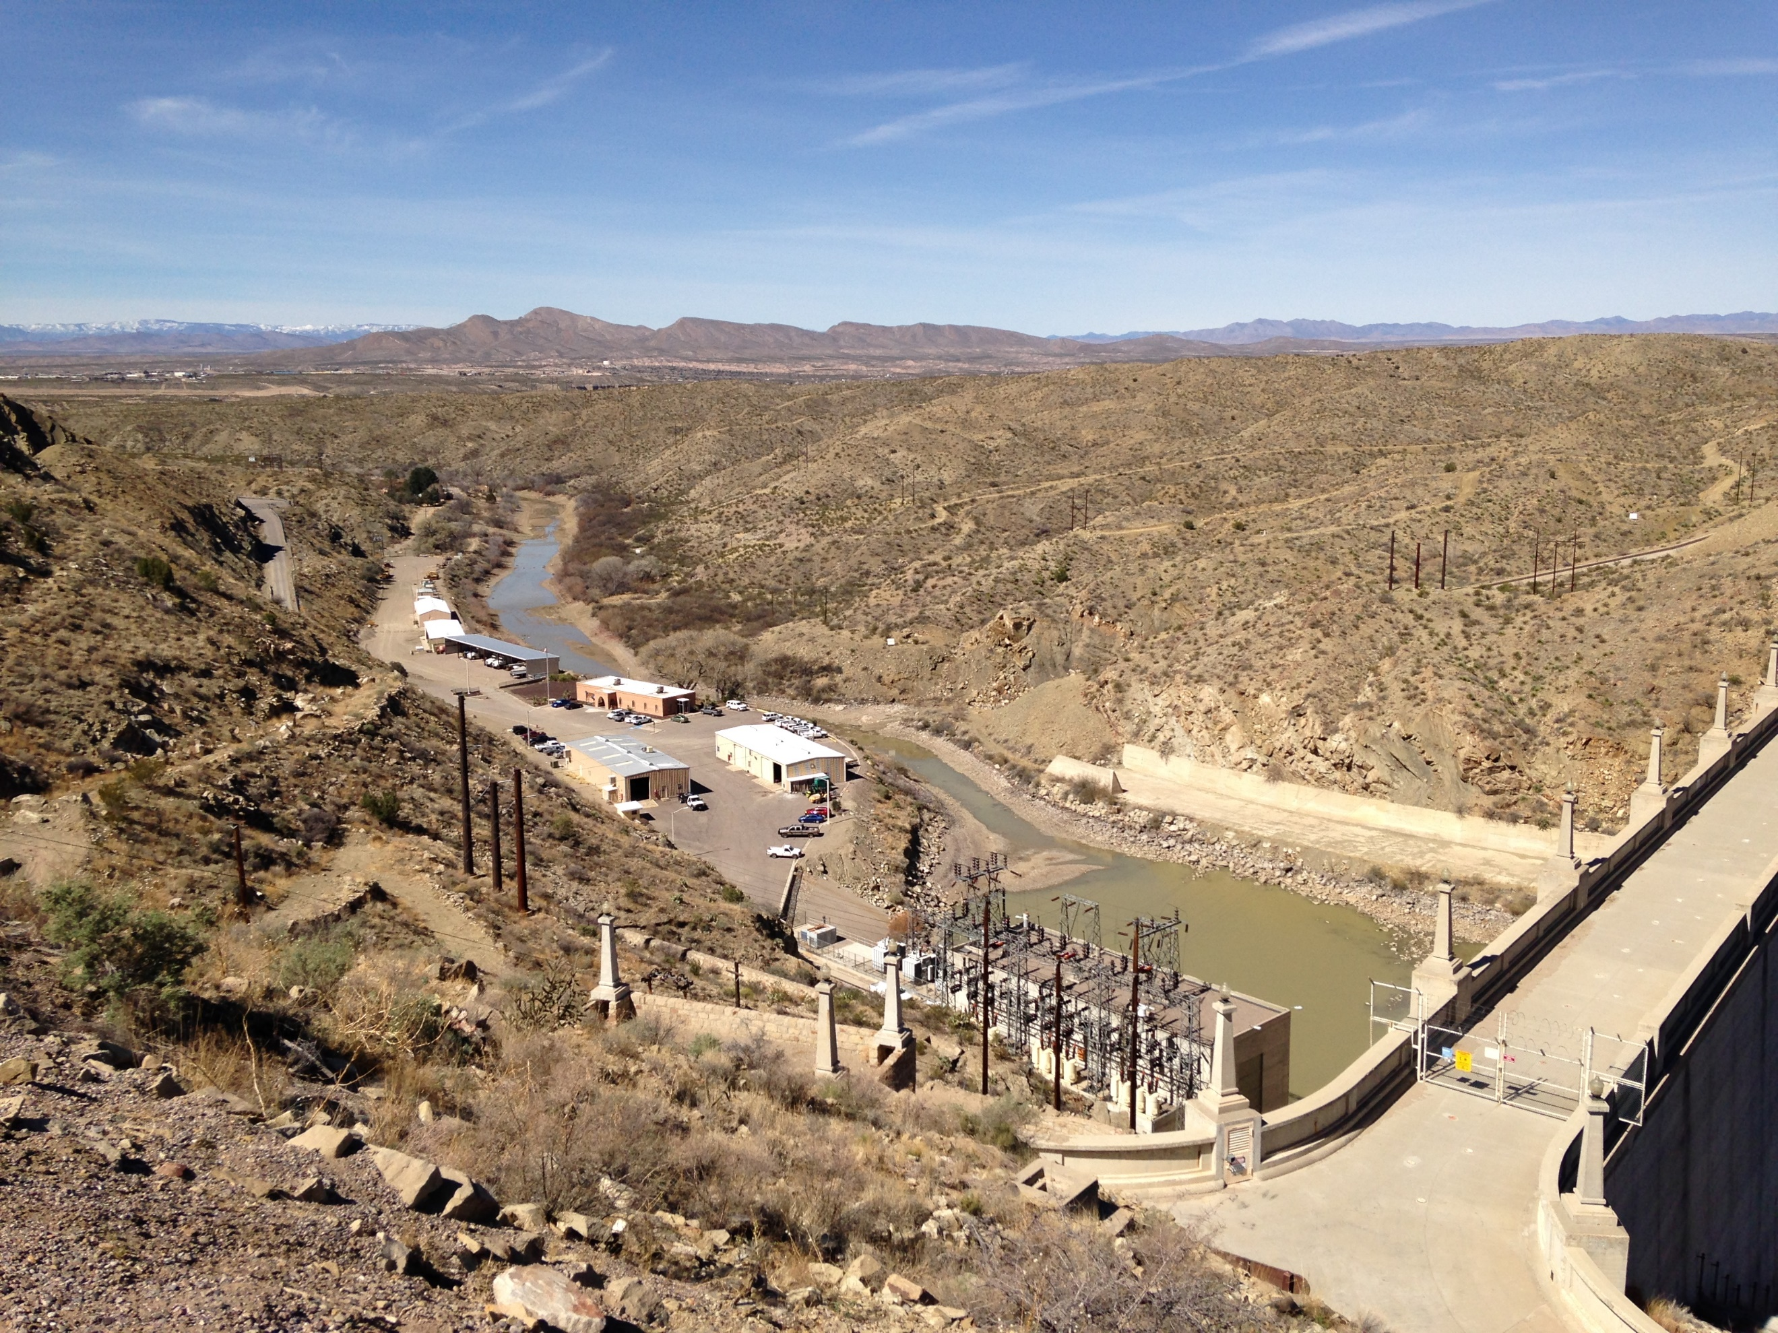

Rio Grande downstream of Elephant Butte, NM. Photo credit: NMED.